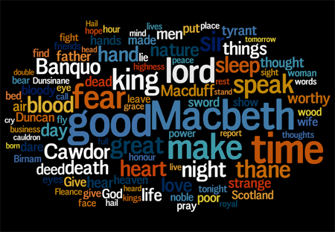
Power & Conflict
Independent Work
Name:____________________
Teacher:___________________

Learning Question: What is Power?
What is the definition of power?
(use lined paper to complete these tasks)

1. What does it mean to be powerful? (AO3)
2. Think about powerful people (See images. What characteristics and qualities do they have?) (AO3)
3. What kinds of power do the pictured people have?
4. Are there different forms of power? Why? (AO3)
5. Where does power come from? (AO3)

6. Which of the people pictured is the most powerful?
You must provide a detailed explanation. (AO3)

7. Which of the people pictured is the least powerful?
You must provide a detailed explanation. (AO3)

8. What does it mean to be powerful? Use your learning to write a more detailed answer than before. (AO3)

A reminder of the
Literature Assessment Objectives...

Lit AO1: Use textual references, including quotations, to support and illustrate interpretations.

Lit AO2: Analyse the language, form and structure used to create meanings and effects, using relevant subject terminology where appropriate.

Lit AO3: Show understanding of the relationships between texts and the contexts in which they were written.

What is corruption?

POWER CORRUPTS.

ABSOLUTE POWER CORRUPTS ABSOLUTELY.

Remember this quote? What does it mean? (AO3)

____________________________________________________________________________________________________________________________________________________________________

Does power lead to corruption?
Scientific research shows that, whatever an individual’s personality type, power leads to antisocial decisions – and testosterone plays an important part too. By John Antonakis.

A few years ago, after a debate over the presidential elections in the USA, a journalist and I began to discuss the case of former Italian prime-minister Silvio Berlusconi. The journalist wanted me to explain why Berlusconi was so power-hungry; what factors might explain his character and his sexual escapades?

I did not want to answer. It was too big a question. However, after persistent questioning, I blurted out a response: “I don’t know. Maybe it is because of his testosterone?”

We know that the hormone testosterone indicates reduced empathy and increased antisocial behaviour, as well as controlling sexual behaviour. So when planning a study on corrupt leaders with my colleagues, I thought it might be interesting to measure testosterone too.

Does power corrupt?
Answering this question is not easy. It is possible that power corrupts, but it is also possible that some individuals seek power because they are already corrupt at heart. We were therefore interested to see if stable qualities that we could measure, such as personality (for example, honesty) or physical factors (such as testosterone levels), mattered for corruption.

To know whether power does corrupt we had to manipulate power; we gave power to a random group of participants and observed how they behaved. We ensured we had roughly equal numbers of similar individuals (honest, smart, corrupt, men, women, etc) in our groups.

We set up two experiments. Participants played what is called a dictator game. The dictator, referred to as the “leader” in the experiment, could decide how to share a sum of money between themselves, and their team. They had to make choices between serving the greater good – doing what’s right for public welfare by increasing the team’s payout – or serving oneself, by increasing their own payout but destroying public welfare.

We also manipulated the number of followers for each leader: the leaders either had one follower (low-power leaders), or several (high-power leaders). We then allowed the leaders to take decisions about payouts.

What did we find?
In the first experiment, results showed that high-power leaders took antisocial decisions at a significantly higher rate than low-power leaders.

Before becoming leaders or followers, we asked participants to vote on what a responsible leader should do with their payouts. Most endorsed the more social option; just 3.33% said that leaders should take antisocial decisions.

Yet, when they became leaders, participants succumbed to the corruptive effects of power. Interestingly, even the most honest individuals, in time, slid down the slippery, corrupting slope of power. Even more interesting was our observation that those who had high levels of testosterone were most corrupt when they had high power.

Our findings have important implications for the design of institutions. Leaders prefer to have the power to make their own decisions and lots of discretion. Yet we know from our study, and others too, that power can go to leaders’ heads.

What is testosterone?

Define ‘succumbed’:

Use it in a new sentence:

List 4 things the study did to find out if power corrupts. (AO1)

1.

2.

3.

4.

List 3 findings from the study. (AO1)

1.

2.

3.

On lined paper, write about a time you succumbed to temptation...

Consolidation Tasks (use lined paper)
Complete the following statements using as much as you’ve learned about power as possible... (AO1&3)
You must use the following words:
ambition, corruption, status.
Power is...
Power can...

Choose three of the images to link to what you learnt about ‘power’ recently. Explain your ideas.
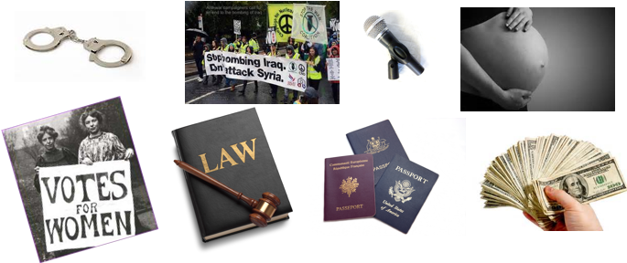

Macbeth: The Simplified Story
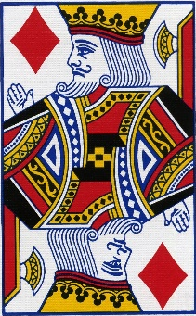
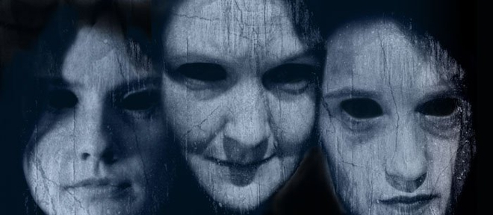
The play begins with the brief appearance of a trio of witches and then moves to a military camp, where the Scottish King Duncan hears the news that his generals, Macbeth and Banquo, have defeated two separate invading armies—one from Ireland and one from Norway.
Following their battle with these enemy forces, Macbeth and Banquo encounter the witches as they cross a moor. The witches prophesy that Macbeth will be made thane (a rank of Scottish nobility) of Cawdor and eventually King of Scotland. They also prophesy that Macbeth’s companion, Banquo, will start a line of Scottish kings, although Banquo will never be king himself.
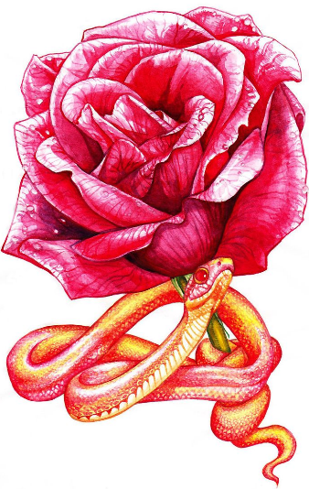
The witches vanish, and Macbeth and Banquo treat their prophecies sceptically until some of King Duncan’s men come to thank the two generals for their victories in battle and to tell Macbeth that he has indeed been named thane of Cawdor. The previous thane betrayed Scotland by fighting for the Norwegians and Duncan has condemned him to death. Macbeth is intrigued by the possibility that the remainder of the witches’ prophecy—that he will be crowned king—might be true, but he is uncertain what to expect. He visits King Duncan, and they plan to dine together at Inverness, Macbeth’s castle, that night. Macbeth writes ahead to his wife, Lady Macbeth, telling her all that has happened.
Lady Macbeth suffers none of her husband’s uncertainty. She desires the kingship for him and wants him to murder Duncan in order to obtain it. When Macbeth arrives at Inverness, she overrides all of her husband’s objections and persuades him to kill the king that very night.
He and Lady Macbeth plan to get Duncan’s two chamberlains drunk so they will black out; the next morning they will blame the murder on the chamberlains, who will be defenceless, as they will remember nothing.
While Duncan is asleep, Macbeth stabs him, despite his doubts and a number of supernatural portents, including a vision of a bloody dagger. When Duncan’s death is discovered the next morning, Macbeth kills the chamberlains—pretending to be outraged at their crime—and soon becomes king. Duncan’s sons Malcolm and Donalbain flee to England and Ireland, respectively, fearing that whoever killed Duncan desires their deaths as well.
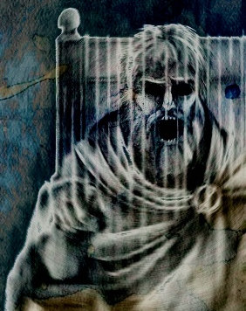
Fearful of the witches’ prophecy that Banquo’s heirs will seize the throne, Macbeth hires a group of murderers to kill Banquo and his son Fleance. They ambush Banquo on his way to a royal feast, but they fail to kill Fleance, who escapes into the night. Macbeth becomes furious: as long as Fleance is alive, he fears that his power remains insecure.
At the feast that night, Banquo’s ghost visits Macbeth. When he sees the ghost, Macbeth raves fearfully, startling his guests, who include most of the great Scottish nobility. Lady Macbeth tries to neutralize the damage, but Macbeth’s kingship now falls under suspicion from his nobles and subjects.
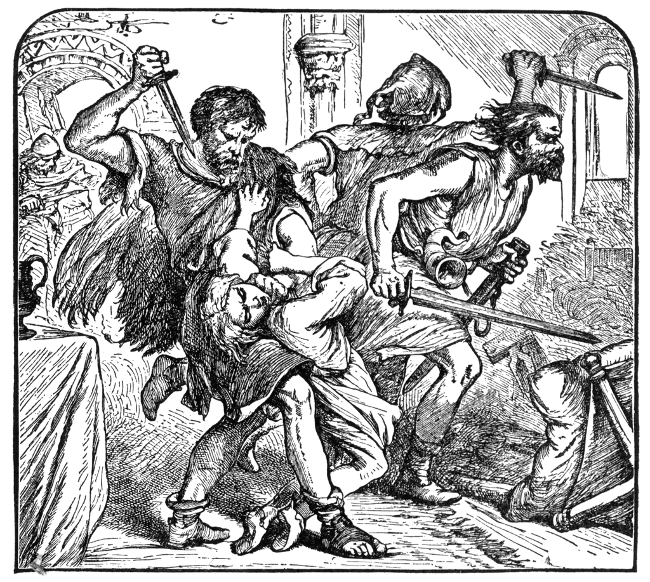
Frightened, Macbeth goes to visit the witches in their cavern. There, they show him a sequence of demons and spirits who present him with further prophecies: he must beware of Macduff, a Scottish nobleman who opposed Macbeth’s accession to the throne; he is incapable of being harmed by any man born of woman; and he will be safe until Birnam Wood comes to Dunsinane Castle. Macbeth is relieved and feels secure, because he knows that all men are born of women and that forests cannot move. When he learns that Macduff has fled to England to join Malcolm, Macbeth orders that Macduff’s castle be seized and, most cruelly, that Lady Macduff and her children be murdered. When news of his family’s execution reaches Macduff in England, he is stricken with grief and vows revenge.
Prince Malcolm, Duncan’s son, has succeeded in raising an army in England, and Macduff joins him as he rides to Scotland to challenge Macbeth’s forces. The invasion has the support of the Scottish nobles, who are appalled and frightened by Macbeth’s tyrannical and murderous behaviour.
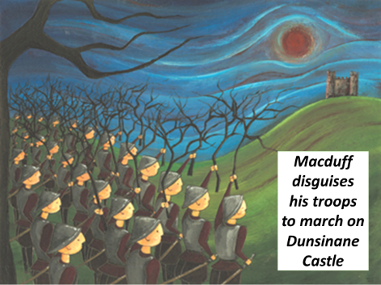
Lady Macbeth, meanwhile, becomes plagued with fits of sleepwalking in which she bemoans what she believes to be bloodstains on her hands. Before Macbeth’s opponents arrive, Macbeth receives news that she has killed herself, causing him to sink into a deep and pessimistic despair.
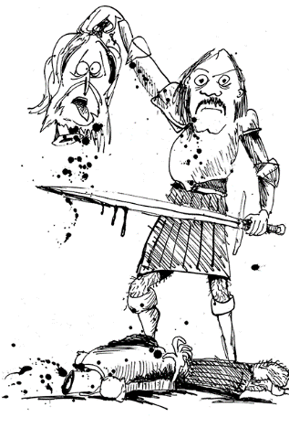
Nevertheless, he awaits the English and fortifies Dunsinane, to which he seems to have withdrawn in order to defend himself, certain that the witches’ prophecies guarantee his invincibility. He is struck numb with fear, however, when he learns that the English army is advancing on Dunsinane shielded with boughs cut from Birnam Wood. Birnam Wood is indeed coming to Dunsinane, fulfilling half of the witches’ prophecy.
In the battle, Macbeth fights violently, but the English forces gradually overwhelm his army and castle. On the battlefield, Macbeth encounters the vengeful Macduff, who declares that he was not “of woman born” but was instead “untimely ripped” from his mother’s womb (what we now call birth by caesarean section). Though he realizes that he is doomed, Macbeth continues to fight until Macduff kills and beheads him. Malcolm, now the King of Scotland, declares his benevolent intentions for the country and invites all to see him crowned at Scone.
Sum up the story in this box – you can draw diagrams, summarise the story or any other method. You must not go outside the box! (AO1)
12-Step Macbeth: Call & Response
1. On a dark, stormy Scottish night, three witches plot to meet Macbeth on his way home from battle.
When shall we three meet again? In thunder, lightning or in rain?
2. Macbeth fought bravely, decapitating his opponent and gaining victory for King Duncan. Exhausted from battle, Macbeth and his friend Banquo meet the witches, who make a prophecy…
All hail Macbeth, that shalt be king hereafter.
3. Lady Macbeth is afraid her husband is too weak-willed to fulfil his destiny. When she hears that King Duncan is coming to their castle, she decides they must kill him and persuades Macbeth to do it…
Look like th’innocent flower, but be the serpent under’t.
4. Lady Macbeth gets the king’s bodyguards drunk, and as they sleep Macbeth murders the king and smears the drunken bodyguards with blood to frame them. He is tortured by what he has done and hears voices in his head.
O, full of scorpions is my mind, dear wife.
5. Macbeth is crowned King of Scotland – and has his friend Banquo killed to keep him quiet about the witches’ prophecy. At his coronation feast Macbeth sees Banquo’s ghost and is terrified.
Quit my sight! Let the earth hide thee!
6. Macbeth meets the witches again, and they give him three messages…
Beware Macduff!
None of woman born shall harm Macbeth.
Macbeth shall never vanquished be until Great Birnam Wood to high Dunsinane Hill shall come against him.
7. Macduff is King Duncan’s loyal servant, so Macbeth attacks his castle and has his family killed.
Give to th’edge o’th’sword his wife, babes, and all…
8. Lady Macbeth feels so guilty that she begins to walk and talk in her sleep – and constantly washes her hands to clean off the blood of those Macbeth has murdered.
Out damned spot! Out I say! Here’s the smell of blood still.
9. Macduff gathers his army near Birnam Wood, close to Dunsinane Castle – but because of the witches prophecies, Macbeth is not worried.
I will not be afraid of death and bane till Birnam Forest come to Dunsinane.
10. Macduff orders his men to chop down branches from the trees and disguise themselves as they march on the castle. Macbeth realises that the second prediction has come true.
And now a wood comes towards Dunsinane.
11. Macbeth is deserted by his men, but stays to fight on – confident that the witches final prediction will protect him – none from a woman borne can harm him. But then he discovers something unexpected…
Turn, hell-hound, turn. Macduff was from his mother’s womb untimely ripped.
12. Macduff kills Macbeth, returning the crown to its rightful owner, Malcolm.
Hail, King of Scotland!!!
Please watch this interpretation of Macbeth. It’s quite traditional, but the director has changed and adapted some aspects of the play, although the storyline is very accurate.

As you watch, make a note of any of the key motifs (symbols) you see appearing on screen or in the dialogue...
________________________________________________________________________________________________________________________________________________________________________________________________________________________________________________________________________________________________________________________________________________________________________________________________________________________________________________________________________________________________________________________________________________________________________________________________________________________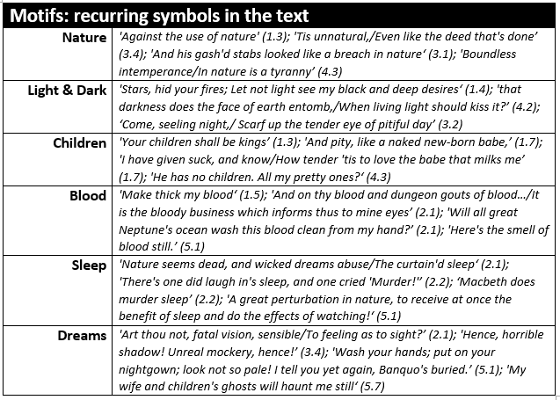
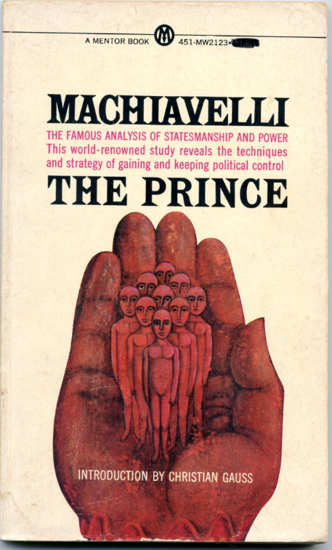
Who was Machiavelli – and
what can he teach us about power?
(use lined paper)
Look at the cover of the book below on the left. What do you think ‘The Prince’ can teach us about power? (AO3)
What do you think the quotation below means?
Explain your answer in as much detail as possible. (AO2 & AO3)

“Since love and fear can hardly exist together, if we must choose between them, it is far safer to be feared than loved”
Niccolo Machiavelli
The Prince

Machiavellianism (AO3)
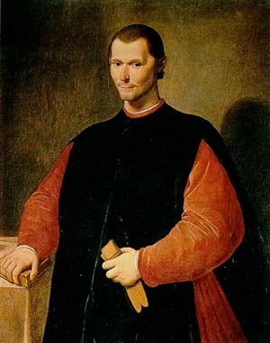
NOTE! The types of political behaviour which are discussed with approval by Machiavelli in The Prince were thought of as shocking by contemporaries, and its immorality is still a subject of serious discussion.

Extract from The Prince
Niccolò Machiavelli, 1532
Every prince may desire to be thought clement. But it was Cesare Borgia's cruelty which brought peace and unity to the Romagna. A prince who keeps his subjects united and loyal, ought not to mind the reproach of cruelty; for too much mercy will allow disorder to injure the whole people, whilst a few executions offend only individuals.
Is it better to be loved or feared? One might wish to be both, but they are not met in the same person. Because this is to be asserted in general of men, that they are ungrateful, fickle, false, cowardly, covetous, and as long as you succeed they are yours entirely. They will offer you their blood, property, life, and children when the need is far distant; but when it approaches they turn against you. The prince who relies on their promises is ruined; because friendships that are obtained by payments, and not by greatness or nobility of mind, may indeed be earned, but they are not secured, and in time of need cannot be relied upon. Men will readily offend a beloved, for love is preserved by the link of obligation which men will break at every opportunity for their advantage; but fear preserves you by a dread of punishment which never fails.
Clement:
Subjects:
Reproach:
Mercy:
Asserted:
Covetous:
Summarise Machiavelli’s argument in fifty words or fewer... (AO1)
__________________________________________________________________________________________________________________________________________________________________________________________________________________________________________________________________________________________________________________________________________________________________________________________
How does this relate to Macbeth’s actions? (AO3)
__________________________________________________________________________________________________________________________________________________________________________________________________________________________________________________________________________________________________________________________________________________________________________________________
Extract from The Prince
Niccolò Machiavelli, 1532
Many men believe the affairs of the world are governed by fortune and God, so that men cannot direct them. Fortune may direct one-half of our actions, but she still leaves us to direct the other half. She may be like the raging flood, which sweeps away trees and buildings. But that does not mean that, when the waters settle, men cannot make barriers against such misfortune.
A man may pursue glory and riches by caution, another with haste, one by force, another by skill, and yet still attain their goal. It is not so much the method, but how well they conform to the spirit of the times. It is the man who cannot change from his nature or his accustomed ways, who is lost. The cautious man who does not know when it is time to turn adventurous is ruined.
Fortune is changeful, yet mankind steadfast in their ways, success comes when the two are in agreement. For my part I consider that it is better to be adventurous than cautious, because fortune is a woman, and if you wish to control her it is necessary to beat and ill-use her; and she allows herself to be mastered by the adventurous. She is, therefore, always, woman-like, a lover of young men, because they are less cautious, more violent, and with more audacity command her.
Haste:
Attain:
Conform:
Accustomed:
Steadfast:
Audacity:
Summarise Machiavelli’s argument in fifty words or fewer... (AO1)
__________________________________________________________________________________________________________________________________________________________________________________________________________________________________________________________________________________________________________________________________________________________________________________________
How does this relate to Macbeth’s actions? (AO3)
__________________________________________________________________________________________________________________________________________________________________________________________________________________________________________________________________________________________________________________________________________________________________________________________

Recap the Plot
Who is travelling with Macbeth when he first encounters the three sisters?  - Macduff  - Lennox  - Banquo  - Duncan  What is Macbeth Thane of at the start of the play?  - Scotland  - Fife  - Cawdor  - Glamis  What prophecy do the sisters give Banquo in Act 1?  - That he will be made Thane of Cawdor  - That his son will be made Thane of Cawdor  - That his sons will be made princes  - That his sons will be made kings  What ‘sign’ convinces Macbeth to kill Duncan?  - An apparition of one of the Weird Sisters  - A nightmare about one of the Weird Sisters  - An apparition of a floating dagger  - The ghost of his dead father visits him  What does Macbeth accidentally take with him after murdering the king?  - The murder weapons  - The king’s crown  - The bible  - The King’s bloody pillow  Which characters run away shortly after Duncan’s death?  - Banquo and Fleance  - Macbeth and Lady Macbeth  - Malcolm and Donalbain  - Macduff and his family  What does Macbeth hire men to do?  - Protect him from assassins  - Kill Macduff and his family  - Find the witches so he can talk to them again  - Kill Banquo and his son | When he sees them the second time, what four things do the witches show Macbeth?  - A head, a blood child, a crown and a serpent  - An armed child, a bloody child, a crowned child with a tree in his hand, eight kings followed by Banquo’s ghost with a mirror  - Armed head, visions, crowned child with a tree in his hand and a battlefield  - An armed head, a bloody child, a crowned child with a tree in his hand, eight kings followed by Banquo’s ghost with a mirror  Why does Macbeth have Macduff's family and servants killed?  - Macduff is not loyal and Macbeth wants to kill his family as they could kill him  - Macduff is not loyal to Macbeth, and Macbeth is angry  - Macduff is angry with Macbeth and he is afraid  - Macduff is not loyal and Macbeth is happy  Towards the end of the play, which words best describe Lady Macbeth's behaviour in this Act?  - Confident, egotistical and boastful  - Ambitious, power-driven and determined  - Psychotic, unstable and melodramatic  - Obsessive, paranoid and unhinged  Macbeth does not fear death at the hands of the rebels because he has...  - Extensive battle experience  - Faith in the witches' prophecies  - Little reason to go on living  - No awareness of the rebels' strength  In the last scene, Macbeth fights to the death because he...  - is given no other choice  - thinks that Macduff can be easily defeated  - does not believe Macduff's claims about his birth  - prefers an honourable defeat to a humiliating surrender

Relevant Vocabulary

Ambition  (noun)  A strong desire to do or achieve something. | Chivalry  (noun)  Bravery, military skill, generosity in victory, courtesy to women | Cowardice  (noun)  Fear and self-concern leading to putting yourself first.
Conflict  (noun)  A serious disagreement or argument. | Desire  (noun)  A strong wish for something or someone. | Duplicity  (noun)  Deceitfulness; being two-faced.
Femininity  (noun)  The quality of being female; womanliness. | Machiavellian  (adjective)  Being cunning, evil and sly. | Masculinity  (noun)  The quality of being male; manliness.
Monarchy  (noun)  The king, queen and royal family of a country. | Paranoia  (noun)  A worry that you are being persecuted or victimised. | Patriarchal  (adjective)  A social system where men (particularly fathers) hold the power and influence.
Prophecy  (noun)  A prediction of the future. | Soliloquy  (noun)  A speech given to the audience. | Superstition  (noun)  A belief in supernatural influences which there are no evidence for.
Tyranny  (noun)  An unfair, unjust and cruel government or rule. | Usurp  (verb)  To take someone else’s place illegally or by force. | Villainy  (noun)  Wicked or criminal behaviour.
Hamartia  (noun)  A fatal flaw leading to the downfall of a tragic hero. | Hubris  (noun)  Excessive pride or confidence. | Catharsis  (noun)  Releasing – and finding release from – strong emotions.

- Write the story Macbeth.
- Use as many of these new words as possible.
- Highlight them once you have done.
- Lang AO5 communicate clearly, effectively and imaginatively
- Lang AO6/Lit AO4 accurate SPaG

12 VOCABULARY QUESTIONS
Which noun means ‘excessive pride or confidence’?  - Hubris.  - Hamartia.  - Machiavellian.  - Villainy.  Which noun is a strong desire to do or achieve something?  - Hamartia.  - Ambition.  - Catharsis.  - Desire.  Which noun means manliness?  - Femininity  - Masculinity.  - Matriarchal.  - Patriarchal.  Which adjective means cunning and sly?  - Machiavellian.  - Patriarchal.  - Ambitious.  - Chivalrous.  Femininity is…  - The quality of being male.  - Being a weak man.  - Rejecting your womanliness.  - The quality of being female.  A prophecy is…  - Encouragement to do bad things.  - Encouragement to do good things.  - Interpreting events in the past.  - A prediction of the future.  A soliloquy is…  - A speech given to the audience.  - A release from strong emotions.  - A belief in the supernatural.  - Another name for the royal family. | Which adjective describes a social system where men hold the power and influence??  - Paternal.  - Patriarchal.  - Maternal.  - Matriarchal.  What is chivalry?  - Cowardice, diplomacy, courtesy.  - Bravery, military skill, courtesy.  - Wicked or criminal behaviour.  - Unfair, unjust and cruel rule.  What is duplicity?  - Honesty and straight-forwardness.  - Excessive pride or confidence.  - A strong desire or wish for someone.  - Deceitfulness or being two-faced.  Which noun is a worry that you are being persecuted or picked on?  - Cowardice.  - Tyranny.  - Catharsis.  - Paranoia.  Which verb means to take someone’s place illegally or by force?  - Usurp.  - Prophesise.  - Tyrannise.  - Desire.  Tyranny is…  - Wicked or criminal behaviour.  - A belief in the supernatural.  - A serious disagreement or argument.  - An unfair, unjust or cruel governance.  Hamartia is...  - A fatal flaw leading to a hero’s downfall.  - Releasing strong emotions.  - A worry you’re being victimised.  - Deceitful behaviour.

Macbeth: Act One
Summary: Act 1, Scene 1
Thunder and lightning crash above a Scottish moor. Three haggard old women, the witches, appear out of the storm. In eerie, chanting tones, they make plans to meet again upon the heath, after the battle, to confront Macbeth. As quickly as they arrive, they disappear.

Rules for Reading
- ‘Thou’ means ‘you’.
- Don’t pause at the end of the line unless the punctuation tells you to.
- Adding ‘eth’ to a verb doesn’t make it Shakespearean.

Act 1, Scene 1: A Desolate Place
hurlyburly: noise and chaos  ere: before  heath: moor  the weird sisters hear their familiar spirits  anon: soon  exeunt: all exit | Thunder and lightning. Enter three Witches  First Witch  When shall we three meet again  In thunder, lightning, or in rain?  Second Witch  When the hurlyburly's done,  When the battle's lost and won.  Third Witch  That will be ere the set of sun.  First Witch  Where the place?  Second Witch  Upon the heath.  Third Witch  There to meet with Macbeth.  First Witch  I come, Graymalkin!  Second Witch  Paddock calls.  Third Witch  Anon.  ALL  Fair is foul, and foul is fair:  Hover through the fog and filthy air.  Exeunt
Why do you think the witches have been interpreted in so many ways in films and on stage?

Macbeth: Act One
Summary: Act 1, Scene 2
At a military camp near his palace at Forres, King Duncan of Scotland asks a wounded captain for news about the Scots’ battle with the Irish invaders, who are led by the rebel Macdonwald. The captain, who was wounded helping Duncan’s son Malcolm escape capture by the Irish, replies that the Scottish generals Macbeth and Banquo fought with great courage and violence. The captain then describes for Duncan how Macbeth slew the traitorous Macdonwald. As the captain is carried off to have his wounds attended to Ross, a Scottish nobleman, enters and tells the king that the traitorous thane of Cawdor has been defeated and the army of Norway repelled. Duncan decrees that the thane of Cawdor be put to death and that Macbeth, the hero of the victorious army, be given Cawdor’s title. Ross leaves to deliver the news to Macbeth.

Act 1, Scene 2: King Duncan’s Camp Near Forres
Key Extract
Sergeant: Doubtful it stood;
As two spent swimmers, that do cling together
And choke their art. The merciless Macdonwald--
Worthy to be a rebel, for to that
The multiplying villanies of nature
Do swarm upon him--from the western isles
Of kerns and gallowglasses is supplied;
And fortune, on his damned quarrel smiling,
Show'd like a rebel's whore: but all's too weak:
For brave Macbeth--well he deserves that name--
Disdaining fortune, with his brandish'd steel,
Which smoked with bloody execution,
Like valour's minion carved out his passage
Till he faced the slave;
Which ne'er shook hands, nor bade farewell to him,
Till he unseam'd him from the nave to the chaps,
And fix'd his head upon our battlements.
DUNCAN: O valiant cousin! worthy gentleman!
[...] No more that thane of Cawdor shall deceive
Our bosom interest: go pronounce his present death,
And with his former title greet Macbeth.
ROSS: I'll see it done.
DUNCAN: What he hath lost noble Macbeth hath won.

Annotate the killer quote here... (AO2)

Additional Tasks
Look up and define the following terms...
Tragic Hero:

Hamartia:

Aristotle’s Elements of a Tragic Hero
Research what this is and write a definition below.
Don’t just copy from the internet – write it in a way you actually understand!
____________________________________________________________________________________________________________________________________________________________________________________________________________________________________________________________________________________________________________________________________________________________________________________________________________________________________________________________________________________________________________________________________________________________________________________________________________________________________________________________________________________________________________________________________________________________________________________________________________________________________________________________________________________________________________________________________________________________________________________________________________________________________________________________________________________________________________________________________________________________________________________________________________________________________
Code of Chivalry and Being Chivalrous
The Code of Chivalry was a moral system which went beyond rules of combat and introduced the concept of Chivalrous conduct - qualities idealised by the Medieval knights such as bravery, courtesy, honour and great gallantry toward women. It also incorporated the notion of courtly love. The Code of Chivalry was the honour code of the knight. The Code of Chivalry was an important part of the society and lives of people who lived during the Medieval times and was understood by all.
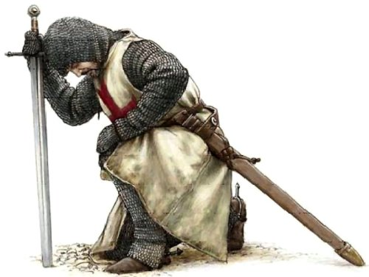
The Knight's Code of Chivalry
A knight was expected to have not only the strength and skills to face combat in the violent era of the Middle Ages but was also expected to temper this aggressive side with a chivalrous side to his nature. The ideals described in the Code of Chivalry were emphasised by the oaths and vows that were sworn in the Knighthood ceremonies of the Middle Ages and the Medieval era. These sacred oaths of combat were combined with the ideals of chivalry and with strict rules of etiquette and codes of conduct towards women.
Code of Chivalry described by the Duke of Burgundy
The chivalric virtues of the Code of Chivalry were also described in the 14th Century by the Duke of Burgundy. The words he chose to use to describe the virtues that should be exhibited in the Knights Code of Chivalry were as follows:
- Faith
- Charity
- Justice
- Prudence
- Resolution
- Truth
- Diligence
- Hope
- Valour

Although Macbeth is a warrior rather than a knight, he would still have been expected to act in a chivalrous fashion. Choose three of the virtues above and explain how Macbeth fails to show them.
1.

2.

3.

Complete the simile used to describe Macbeth’s performance in battle: ‘Like Valour’s _________’  - Million  - Soldier  - Warrior  - Minion | What prophecy do the sisters give Banquo in Act 1?  - That he will be made Thane of Cawdor  - That his son will be made Thane of Cawdor  - That his sons will be made princes  - That his sons will be made kings

How do writers consciously construct powerful characters?
Before we even meet him, we know that Macbeth
is a hugely powerful character. How?
Macbeth’s Power

Read the Act 1, Scene 2 and the extract from Macbeth.
Choose 3 quotes which show different types of power Macbeth displays (AO1) |  | Explain what type of power each of them shows (AO2)
How does Shakespeare show Macbeth’s power in this extract?
How does the writer achieve it?  Identify a technique/interesting use of language  Use a quote | Why is it effective?  Link to the actual words used  What does it make you feel/do?  What are the connotations?  Does it have an emotional impact? |  | Context  Does it link to ideas and beliefs about chivalry?  Does it link to Machiavellian ideas about power?
Lit AO1: Use textual references, including quotations, to support and illustrate interpretations. | Lit AO1: Read, understand and respond to texts, maintain a critical style and develop an informed personal response.  Lit AO2: Analyse the language, form and structure used to create meanings and effects, using relevant subject terminology where appropriate. |  | Lit AO3: Show understanding of the relationships between texts and the contexts in which they were written.
Potential sentence starters…
- Shakespeare makes the audience favour Macbeth by…
- However, on closer inspection…

Macbeth: Act One
Summary: Act 1, Scene 3
On the heath near the battlefield, thunder rolls and the three witches appear. Suddenly a drum beats, and the third witch cries that Macbeth is coming.

Macbeth and Banquo come upon the witches and shrink in horror at the sight of the old women. The witches hail Macbeth as thane of Glamis (his original title) and as thane of Cawdor. Macbeth is baffled by this second title, as he has not yet heard of King Duncan’s decision. The witches also declare that Macbeth will be king one day. Stunned and intrigued, Macbeth presses the witches for more, but they have turned their attention to Banquo. They tell Banquo that he will never be king but that his children will sit upon the throne. The witches vanish into thin air.

In disbelief, Macbeth and Banquo discuss the strange encounter. Their conversation is interrupted by the arrival of Ross and Angus who tell Macbeth that the king has made him thane of Cawdor, as the former thane is to be executed for treason.

Macbeth ignores his companions and speaks to himself, ruminating upon the possibility that he might one day be king. He wonders whether the reign will simply fall to him or whether he will have to perform a dark deed in order to gain the crown.

Witches and Witchcraft in Shakespeare’s Time
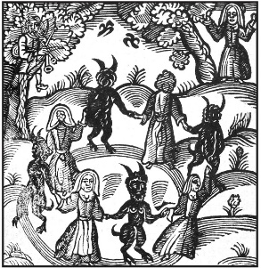
Throughout the ages there have been people who have believed in witches and witchcraft. The people of Shakespeare’s day were no different. Shakespeare drew on the popular traditions of his time and used them for his own purposes. In Macbeth he used popular beliefs about witches and witchcraft.
When Shakespeare wrote Macbeth, witchcraft was a topic of considerable interest. The new king of England, James I, had written a book called Demonology which was published in 1597. Until the time of Queen Elizabeth, no-one could be executed simply for being a witch. But in 1604, witchcraft became a capital offence. Evidence of a relationship with evil spirits condemned a suspect to death by hanging, burning or drowning. Whether Shakespeare himself believed in witches does not matter. He used them for his play, and many of his audience would have believed in them as thoroughly evil servants of the devil. For the people of Shakespeare’s time, the devil was very real who they believed spent his time trying to trap men and women into his power.
Witches were supposed to be capable of doing all the things that the three weird sisters are said to perform in Macbeth. It was believed that they could see into the future; that they could create storms, hail, thunder and lightning; stop the sun and change night into day and day into night. In order to work their charms they would open graves and steal parts of the bodies to make potions. For this purpose the bodies of unbaptized babies were especially prized. And witches could call up the dead.
For a king like Macbeth to visit and have dealings with witches would have seemed both a crime and a sin.
Macbeth is easily captured by their power and by their prophecies. But note that they never tell him a lie. However, they do allow him to deceive himself. The devil does not lie...but leads us into temptation.
Identify four things people believed about witches... (AO1)
1.
2.
3.
4.
What was the penalty for witchcraft? (AO1)

Nouns are things. There are several different types of nouns:
Concrete nouns
Things that are tangible/you can touch and see. These are divided into two categories:
- Common nouns – table, chair, cheese, witch
- Proper nouns – Sheffield, Macbeth, Forres, Scotland
Abstract nouns
Ideas and concepts that don’t physically exist: love, happiness, depression, confusion, madness.
Tasks
- Annotate the witches’ use of nouns in Act 1 scene 3.
- What kinds of nouns are used?
- Which semantic fields do these belong to?
- On lined paper: What does this tell us about people’s views of witches and the supernatural?
- On lined paper: Why do you think Shakespeare included the witches in Macbeth – and why are they the first thing the audience sees in Act 1, Scene 1?

Why was the original Thane of Cawdor executed?  - He was believed to be a witch.  - He committed treason against King Duncan.  - He killed the Queen.  - He refused to fight as he was a coward.  What is Macbeth Thane of at the start of the play?  - Scotland  - Fife  - Cawdor  - Glamis  Which characters use the thematic paradox, ‘Fair is foul…’ in Act 1?  - Macbeth and Banquo  - The Weird Sisters  - The Weird Sisters and Macbeth  - The Weird Sisters and Banquo |  | What is duplicity?  - Honesty and straight-forwardness.  - Excessive pride or confidence.  - A strong desire or wish for someone.  - Deceitfulness or being two-faced.  Which noun is a worry that you are being persecuted or picked on?  - Cowardice.  - Tyranny.  - Catharsis.  - Paranoia.  Which verb means to take someone’s place illegally or by force?  - Usurp.  - Prophesise.  - Tyrannise.  - Desire.

Act 1, Scene 3: A Heath
Thunder. Enter the three Witches
First Witch: Where hast thou been, sister?
Second Witch: Killing swine. [...]
Third Witch: A drum, a drum!
Macbeth doth come.
Enter MACBETH and BANQUO
MACBETH: So foul and fair a day I have not seen.
BANQUO: How far is't call'd to Forres? What are these
So wither'd and so wild in their attire,
That look not like the inhabitants o' the earth,
And yet are on't? Live you? or are you aught
That man may question? You seem to understand me [...]
MACBETH: Speak, if you can: what are you?
First Witch: All hail, Macbeth! hail to thee, thane of Glamis!
Second Witch: All hail, Macbeth, hail to thee, thane of Cawdor!
Third Witch: All hail, Macbeth, thou shalt be king hereafter!
BANQUO: Good sir, why do you start; and seem to fear
Things that do sound so fair? [...] My noble partner
You greet with present grace and great prediction
Of noble having and of royal hope,
That he seems rapt withal: to me you speak not.
If you can look into the seeds of time,
And say which grain will grow and which will not,
Speak then to me [...]
First Witch: Lesser than Macbeth, and greater.
Second Witch: Not so happy, yet much happier.
Third Witch
Thou shalt get kings, though thou be none:
So all hail, Macbeth and Banquo!
First Witch: Banquo and Macbeth, all hail!
MACBETH: Stay, you imperfect speakers, tell me more:
By Sinel's death I know I am thane of Glamis;
But how of Cawdor? the thane of Cawdor lives,
A prosperous gentleman; and to be king
Stands not within the prospect of belief,
No more than to be Cawdor. Say from whence
You owe this strange intelligence? or why
Upon this blasted heath you stop our way
With such prophetic greeting? Speak, I charge you.
Witches vanish
BANQUO: [...] Whither are they vanish'd?
MACBETH: Into the air; and what seem'd corporal melted
As breath into the wind. Would they had stay'd!
[...] Your children shall be kings.
BANQUO: You shall be king.
MACBETH: And thane of Cawdor too: went it not so?
BANQUO: To the selfsame tune and words. Who's here?
Enter ROSS and ANGUS
ANGUS: [...] We are sent
To give thee from our royal master thanks [...]
ROSS: And, for an earnest of a greater honour,
He bade me, from him, call thee thane of Cawdor [...]
BANQUO: What, can the devil speak true?
MACBETH: The thane of Cawdor lives: why do you dress me
In borrow'd robes?
ANGUS: Who was the thane lives yet;
But under heavy judgment bears that life
Which he deserves to lose.
MACBETH: [...] [Aside]
This supernatural soliciting
Cannot be ill, cannot be good: if ill,
Why hath it given me earnest of success,
Commencing in a truth? I am thane of Cawdor:
If good, why do I yield to that suggestion
Whose horrid image doth unfix my hair
And make my seated heart knock at my ribs,
Against the use of nature? Present fears
Are less than horrible imaginings:
My thought, whose murder yet is but fantastical,
Shakes so my single state of man that function
Is smother'd in surmise, and nothing is
But what is not.
[...]If chance will have me king, why, chance may crown me, without my stir.
Important Quotation | Important Quotation
Important Quotation | Important Quotation

Annotate the killer quote here...

King James, Witch Trials and Daemonologie
The North Berwick witch trials were the trials in 1590 of a number of Scottish people accused of witchcraft. They ran for two years and implicated seventy people. The confessions of the ‘witches’ were extracted by torture in Edinburgh.
As King James sailed to Copenhagen to marry Princess Anne of Denmark, a terrible storm hit their ship, causing them to seek shelter in Norway for several weeks. Somehow, this was blamed on various women in Denmark who confessed (probably after being tortured) to raising the storm through sorcery. Two were burned for their crime.
Scottish women were linked to the storms when Gillis Duncan confessed to her employer that she had developed an ability to heal herself. She would also regularly sneak out after dark. She could not explain her strange behaviour, so she was tortured – a result of which was her confession of witchcraft. She accused many others too.
The situation snowballed, with more than a hundred suspects arrested. Under torture, many confessed to meeting with the Devil and devoting themselves to his evil work – including poisoning the king and attempting to sink his ship.
King James established a court hear their trials. Two of the most horrific cases are detailed below...
Agnes Sampson
Sampson was an elderly woman who refused to confess. She suffered horribly – she was fastened to the wall of her cell by a witch’s bridle, an iron instrument with four sharp prongs forced into the mouth, so that two prongs pressed against the tongue, and two others against the cheeks. She was kept without sleep and strangled. Only after these ordeals did she confess to her ‘crimes’. She was hanged and burned as a witch.
Dr John Fian
Like Sampson, he refused to confess to witchcraft. His fingernails were forcibly removed, with iron pins thrust into his fingertips. Thumbscrews are also used to slowly crush his thumbs. A similar device called ‘the boot’ was used to crush his feet. He was finally burned at the stake having confessed.
Influenced by his involvement in the ‘attack’ upon his boat and his role in the subsequent trials, King James wrote his book Daemonologie in 1597.
DAEMONOLOGIE (edited extract)
My intention in this book, is only to prove two things, as I have already said: the one, that such devilish arts exist. The other, what exact trial and severe punishment they deserve: & therefore reason I, what kind of things are possible to be performed in these arts, & by what natural causes they may be, not that I touch every particular thing of the Devil’s power.
I say and prove, that Witches can, by the power of their Master, cure or cast on diseases: Now by these same reasons, that proves their power by the Devil of diseases in generally is as well proved their power in special: as of weakening the nature of some men, to make them unable for women: and making it to abound in others, more then the ordinary course of nature would permit. And such like in all other particular sicknesses.
How do you think what you’ve learned about King James I and Daemonologie influenced Shakespeare’s writing of Macbeth? (AO3)

What is pathetic fallacy?

Storm on the Island
We are prepared: we build our houses squat,
Sink walls in rock and roof them with good slate.
The wizened earth had never troubled us
With hay, so as you can see, there are no stacks
Or stooks that can be lost. Nor are there trees
Which might prove company when it blows full
Blast: you know what I mean - leaves and branches
Can raise a chorus in a gale
So that you can listen to the thing you fear
Forgetting that it pummels your house too.
But there are no trees, no natural shelter.
You might think that the sea is company,
Exploding comfortably down on the cliffs
But no: when it begins, the flung spray hits
The very windows, spits like a tame cat
Turned savage. We just sit tight while wind dives
And strafes invisibly. Space is a salvo.
We are bombarded by the empty air.
Strange, it is a huge nothing that we fear.

Seamus Heaney

How does Seamus Heaney use pathetic fallacy to create a fearful atmosphere? (AO2)

You must refer to pathetic fallacy, you must use the word ‘atmosphere’, you must at least use two quotations.

____________________________________________________________________________________________________________________________________________________________________________________________________________________________________________________________________________________________________________________________________________________________________________________________________________________________________________________________________________________________________________________________________________________________________________________________________________________________________________________________________________________________________________________________________________________________________________________________________________________________________________________________________________________________________________________________________________________________________________________________________________________

Shakespeare does not describe the heath where Macbeth and Banquo meet the witches. You must write a description of the heath, using pathetic fallacy and some of the descriptive writing techniques we’ve used in the past.
- Lang AO5 communicate clearly, effectively and imaginatively
- Lang AO6/Lit AO4 accurate SPaG
- Start in the centre and zoom out/start with a wide view and zoom in
- Describe a sound and then reveal what is causing it.
- Describe something normal and then spot something about it that is abnormal.
- Describe the feeling of the place.
- Describe the movement of an object or part of the object.
- Describe the main source of light and how it touches things in the scene.
- Describe a change in temperature.
- Describe the light and how it falls on things.
________________________________________________________________________________________________________________________________________________________________________________________________________________________________________________________________________________________________________________________________________________________________________________________________________________________________________________________________________________________________________________________________________________________________________________________________________________________________________________________________________________________________________________________________________________________________________________________________________________________________________________________________________________________________________________________________________________________________________________________________________________________________________________________________________________________________________________________________________________________________________________________________________________________________________________________________________________________________________________________________________________________________________________________________________________________________________________________________________________________________________________________________________________________________________________________________________________________________________________________________________________________________________________________________________________________________________________________________________________________________________________________________________________________________________________________________________________________________________________________________________________________________________________________________________________________________________________________________________________________________________________________________________________________________________________
Macbeth: Act One
Summary: Act 1, Scene 4
At the king’s palace, Duncan hears of Cawdor’s execution from his son Malcolm, who says that Cawdor died nobly, confessing and repenting his crimes. Macbeth and Banquo enter. Duncan thanks them profusely for their heroism, and they profess their loyalty and gratitude toward Duncan. Duncan announces he will name Malcolm heir to his throne. Macbeth declares his joy - but knows Malcolm now stands between him and the crown. Plans are made for Duncan to dine at Macbeth’s castle that evening, and Macbeth goes ahead of the royal party to inform his wife of the king’s visit.

Act 1, Scene 4: Duncan’s Palace At Forres

Duncan tells Macbeth he’ll name Malcolm his heir.
Sons, kinsmen, thanes,
And you whose places are the nearest, know
We will establish our estate upon
Our eldest, Malcolm, whom we name hereafter
The Prince of Cumberland

Before he leaves, Macbeth tells the audience...
Stars, hide your fires;
Let not light see my black and deep desires:
The eye wink at the hand; yet let that be,
Which the eye fears, when it is done, to see.

After he’s gone, Duncan tells Banquo...
True, worthy Banquo; he is full so valiant,
And in his commendations I am fed;
It is a banquet to me. Let's after him,
Whose care is gone before to bid us welcome:
It is a peerless kinsman.

Based on the quotations above, why is Macbeth’s potential betrayal of Duncan so appalling? (AO1, AO2, AO3)

________________________________________________________________________________________________________________________________________________________________________________________________________________________________________________________________________________________________________________________________________________________________________________________________________________________________________________________________________________________________________________________________________________________________________________________________________________________________________________________________________________________________________________________________________________________________________________________________________________________________________________________________________
Eve and the Serpent
God took some clay from the ground and made the shape of a man. Then He breathed gently into the shape. The man's eye's opened and he began to live. God called him Adam.
The Lord made a beautiful garden for him to live in. The garden, called Eden, was full of many wonderful things. Beautiful flowers grew everywhere. Birds sang in the trees, streams flowed through the valley and animals roamed across the fields. God brought all the animals to Adam one at a time to be given their names. "Elephant", he would say, or "Tiger", or "Porcupine".
God had made the man in His image to keep Him company and look after the world. But God felt sorry for Adam. "None of these animals is really like him," thought God, "he needs someone to share his life. Someone who cares for him and who he can care for."
That night, God took a rib from Adam's side and made a woman. When Adam awoke the following morning, he found a wife, Eve, lying asleep beside him. Adam was so happy. He took her hand and she woke up. She looked up at him and smiled.
God told the man and woman that it was their job to take care of their new home. God blessed them, saying, "All this is for you. Help yourself to anything you like. But never touch the tree in the middle of the Garden. That tree gives knowledge of good and evil. The day you eat its fruit, you will die."
God did not mean that Adam and Eve would drop down dead the moment they ate the fruit from the tree. He meant that in time they would die without His Spirit dwelling in them.
One day, Adam and Eve were gathering berries for dinner when she heard a silky voice behind her. "Has God told you that you can eat the fruit from all the trees?" the voice asked softly. Eve turned around to see a snake talking to her.
"God has told us we can eat all the fruit except for what grows on The Tree of the Knowledge of Good and Evil," Eve told the serpent.
"Oh come now, that's silly! I hardly think such a lovely fruit would do you any harm," the serpent lied. "God knows that if you eat from The Tree of the Knowledge of Good and Evil you'll become just like God, and will be able to decide for yourself what is right and what is wrong."
The woman looked at the fruit and thought how tasty it looked. She thought how wonderful it would be to be as wise and powerful as God. She believed the serpent's lie and ate the fruit and also gave some to Adam, who was with her, and he took a bite as well.
She felt a strange feeling in the pit of her stomach. She fidgeted and wondered what was wrong with her. Suddenly she realized that she was feeling guilty - she had disobeyed God and knew she'd done something wrong.
As soon as they ate the fruit a change came over Adam and Eve. They became unhappy and fearful of God.

Adam and Eve heard God calling them. Without thinking, they dived into the bushes, but God knew where they were. When God asked them if they had eaten from The Tree of the Knowledge of Good and Evil that He had told them not to touch, they blamed each other for their sins.
God was sad that Adam and Eve had disobeyed them. He told them that they had to leave the Garden of Eden, "From now on you'll have to scratch a living from the soil. You'll need to make clothes and grow food. Nothing will come easily - not even childbirth. And one day, you will die."
Summarise the story in fifty words or fewer. (AO1)
______________________________________________________________________________________________________________________________________________________________________________________________________________________________________________________________________________________________________________________________________________________________

Original Sin
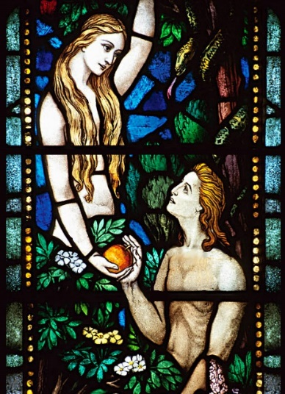
The concept of Original Sin refers generally to the Christian belief in the universal nature of sin. Sin came to the world after Adam and Eve’s behaviour in the Garden of Eden, and Christians believe that ever since that time, all people are born sinful.
Because sin is something we are born with and carry throughout our lives, the only way we can be free of sin is through living good and well-behaved lives.
Christianity would have been far more important in the Jacobean era, and the idea of ‘original sin’ living within us – and being the fault of a woman – would have been common.

What links can you make between the story of the serpent and the story of Macbeth? (AO3)

______________________________________________________________________________________________________________________________________________________________________________________________________________________________________________________________________________________________________________________________________________________________________________________________________________________________________________________________________________________________________________________________________________________________________________________________________________________________________________________________________________________________________________________________________________________________________________________________________________________________________________________________________________________________________________________________________________

Extension: who is more full of ‘original sin’: Macbeth or Lady Macbeth?
______________________________________________________________________________________________________________________________________________________________________________________________________________________________________________________________________________________________________________________________________________________________
The Role of Women
Patriarchal Society
Elizabethan society was patriarchal, meaning that men were considered to be the leaders and women their inferiors. Women were regarded as "the weaker sex", not just in terms of physical strength, but emotionally too. It was believed that women always needed someone to look after them. If they were married, their husband was expected to look after them. If they were single, then their father, brother or another male relative was expected to take care of them.

Housewives and Mothers
Even though there had been an unmarried woman on the throne in Elizabethan England, the roles of women in society were very limited. There were very clear expectations of men and women, and in general men were expected to be the breadwinners and women to be housewives and mothers. On average, a woman gave birth to a child every two years, but as a lot of babies and children died from sickness, families were not always large. Childbearing was considered a great honour to women, as children were seen as blessings from God.

Professional Women
Women were not allowed to enter the professions i.e law, medicine, politics, but they could work in domestic service as cooks, maids, etc. Women were also allowed to write works of literature, providing the subject was suitable for women: mainly translations or religious works. Women were not allowed to act on the public stage or write for the public stage. Acting was considered dishonourable for women. In Shakespeare's plays, the roles of women were often played by young boys.

Marriage
A man was considered to be the head of a marriage, and he had the legal right to chastise his wife. However, it is important to understand what this "headship" meant. It did not mean, as if often supposed, that the husband was able to command his wife to do anything he pleased. He was expected to take care of her, make sure she had everything she needed, and most importantly to love her and be a good father to any children they had. If a husband felt the need to chastise his wife, then he was not allowed to be cruel or inflict bodily harm. If he did abuse his wife, then he could be prosecuted or prevented from living with her. There was no divorce: marriage generally lasted as long as the couple both lived.
(AO1) Sum up each heading in one sentence:
Patriarchal Society

Housewives and Mothers

Professional Women

Marriage

Macbeth: Act One
Summary: Act 1, Scene 5
In Macbeth’s castle, Lady Macbeth reads a letter she has received from Macbeth. It announces Macbeth’s promotion to the thaneship of Cawdor and details his meeting with the witches. Lady Macbeth murmurs that she knows Macbeth is ambitious, but fears he is too full of “th’ milk of human kindness” to take the steps necessary to make himself king. She resolves to convince her husband to do whatever is required to seize the crown. As she awaits her husband’s arrival, she resolves to put her natural femininity aside so that she can do the bloody deeds necessary to seize the crown. Macbeth enters, and they discuss the king’s forthcoming visit. Macbeth tells his wife that Duncan plans to depart the next day, but Lady Macbeth declares that the king will never see tomorrow and to leave the plan to her.

Act 1, Scene 5: Macbeth’s Castle at Inverness
How is Lady Macbeth presented in her first soliloquy?
This is our introduction to Lady Macbeth. She makes this speech after she read Macbeth’s letter about his meeting with the witches and becoming thane of Cawdor.
First Impressions of Lady Macbeth

Read the Lady Macbeth’s soliloquy.
Annotate to show your understanding.
Glamis thou art, and Cawdor; and shalt be
What thou art promised: yet do I fear thy nature;
It is too full o' the milk of human kindness
To catch the nearest way: thou wouldst be great;
Art not without ambition, but without
The illness should attend it: what thou wouldst highly,
That wouldst thou holily; wouldst not play false,
And yet wouldst wrongly win: thou'ldst have, great Glamis,
That which cries 'Thus thou must do, if thou have it;
And that which rather thou dost fear to do
Than wishest should be undone.' Hie thee hither,
That I may pour my spirits in thine ear;
And chastise with the valour of my tongue
All that impedes thee from the golden round,
Which fate and metaphysical aid doth seem
To have thee crown'd withal.

How is Lady Macbeth presented in her first soliloquy?
Killer Quotes |  | What do they show?
How is Lady Macbeth presented in her first soliloquy?
How does the writer achieve it?  Identify a technique/interesting use of language  Use a quote | Why is it effective?  Link to the actual words used  What does it make you feel/do?  What are the connotations?  Does it have an emotional impact? |  | Context  Does it link to Jacobean society, values or beliefs?  Does it link to Machiavellian ideas about power?  How does it relate to women’s role in Jacobean society?
Lit AO1: Use textual references, including quotations, to support and illustrate interpretations. | Lit AO1: Read, understand and respond to texts, maintain a critical style and develop an informed personal response.  Lit AO2: Analyse the language, form and structure used to create meanings and effects, using relevant subject terminology where appropriate. |  | Lit AO3: Show understanding of the relationships between texts and the contexts in which they were written.

What is original sin?  - A speech given to the audience.  - A release from strong emotions.  - A belief in the supernatural.  - Another name for the royal family. |  |  | A soliloquy is…  - A speech given to the audience.  - A release from strong emotions.  - A belief in the supernatural.  - Another name for the royal family.
How is Lady Macbeth presented in her speech to Macbeth?
Read the extract.
Annotate to show your understanding.
LADY MACBETH: Come, you spirits
That tend on mortal thoughts, unsex me here,
And fill me from the crown to the toe top-full
Of direst cruelty! make thick my blood;
Stop up the access and passage to remorse,
That no compunctious visitings of nature
Shake my fell purpose, nor keep peace between
The effect and it! [...] Come, thick night,
And pall thee in the dunnest smoke of hell,
That my keen knife see not the wound it makes,
Nor heaven peep through the blanket of the dark,
To cry 'Hold, hold!'

Enter MACBETH

MACBETH: [...] Duncan comes here to-night.

LADY MACBETH: And when goes hence?

MACBETH: To-morrow, as he purposes.

LADY MACBETH: O, never
Shall sun that morrow see!
Your face, my thane, is as a book where men
May read strange matters. To beguile the time,
Look like the time; bear welcome in your eye,
Your hand, your tongue: look like the innocent flower,
But be the serpent under't. He that's coming
Must be provided for: and you shall put
This night's great business into my dispatch [...]
Only look up clear;
To alter favour ever is to fear:
Leave all the rest to me.

Killer Quotes |  | What do they show?
How is Lady Macbeth presented in her speech to Macbeth?
How does the writer achieve it?  Identify a technique/interesting use of language  Use a quote | Why is it effective?  Link to the actual words used  What does it make you feel/do?  What are the connotations?  Does it have an emotional impact? |  |  | Context  Does it link to Jacobean society, values or beliefs?  Does it link to Machiavellian ideas about power?  How does it relate to women’s role in Jacobean society?
Lit AO1: Use textual references, including quotations, to support and illustrate interpretations. | Lit AO1: Read, understand and respond to texts, maintain a critical style and develop an informed personal response.  Lit AO2: Analyse the language, form and structure used to create meanings and effects, using relevant subject terminology where appropriate. |  |  | Lit AO3: Show understanding of the relationships between texts and the contexts in which they were written.

Where is Macbeth set?  - England  - Ireland  - Scotland  - Wales  Complete the simile used to describe Macbeth’s performance in battle: ‘Like Valour’s _________’  - Million  - Soldier  - Warrior  - Minion  What is Macbeth Thane of at the start of the play?  - Scotland  - Fife  - Cawdor  - Glamis  True or False: The penalty for treason (being a traitor to the king) is life in prison.  - True  - False  My Last Duchess  That’s my last Duchess painted on the wall,  Looking as if she were alive. I call  That piece a wonder, now: Fra Pandolf’s hands  Worked busily a day, and there she stands.  Will’t please you sit and look at her? I said  “Fra Pandolf” by design, for never read  Strangers like you that pictured countenance,  The depth and passion of its earnest glance,  But to myself they turned (since none puts by  The curtain I have drawn for you, but I)  And seemed as they would ask me, if they durst,  How such a glance came there; so, not the first  Are you to turn and ask thus. Sir, ’twas not  Her husband’s presence only, called that spot  Of joy into the Duchess’ cheek: perhaps  Fra Pandolf chanced to say “Her mantle laps  Over my lady’s wrist too much,” or “Paint  Must never hope to reproduce the faint  Half-flush that dies along her throat”: such stuff  Was courtesy, she thought, and cause enough  For calling up that spot of joy. She had  A heart—how shall I say?—too soon made glad,  Too easily impressed; she liked whate’er  She looked on, and her looks went everywhere.  Sir, ’twas all one! My favour at her breast,  The dropping of the daylight in the West,  The bough of cherries some officious fool  Broke in the orchard for her, the white mule  She rode with round the terrace—all and each | What is the name given to the hero's fatal flaw?  - hermertia  - hamartia  - hermian  - hermitia  Hubris is a quality that tragic heroes should possess, according to Aristotle, but what does it mean?  - Fatal flaw  - Reversal of fortune  - Excessive pride  - Good judgement  What was not a common punishment for suspected witches in the 1600s?  - Burning  - Forced labour  - Ducking and drowning  - Pricking of the skin  Which verb means to take someone’s place illegally or by force?  - Usurp.  - Prophesise.  - Tyrannise.  - Desire.  Would draw from her alike the approving speech,  Or blush, at least. She thanked men,—good! but thanked  Somehow—I know not how—as if she ranked My gift of a nine-hundred-years-old name  With anybody’s gift. Who’d stoop to blame  This sort of trifling? Even had you skill  In speech—(which I have not)—to make your will  Quite clear to such an one, and say, “Just this  Or that in you disgusts me; here you miss,  Or there exceed the mark”—and if she let  Herself be lessoned so, nor plainly set Her wits to yours, forsooth, and made excuse,  —E’en then would be some stooping; and I choose  Never to stoop. Oh sir, she smiled, no doubt,  Whene’er I passed her; but who passed without  Much the same smile? This grew; I gave commands;  Then all smiles stopped together. There she stands  As if alive. Will’t please you rise? We’ll meet  The company below, then. I repeat, The Count your master’s known munificence  Is ample warrant that no just pretence  Of mine for dowry will be disallowed;  Though his fair daughter’s self, as I avowed  At starting, is my object. Nay, we’ll go  Together down, sir. Notice Neptune, though,  Taming a sea-horse, thought a rarity,  Which Claus of Innsbruck cast in bronze for me!  Robert Browning

How do My Last Duchess and Macbeth explore the importance of having a ‘public face’ and a ‘private face’? Answer on lined paper. Use the space below to gather your evidence...

Is Macbeth as much to blame for the demise of LM as the Duke is for that of the Duchess? Answer on lined paper. Use the space below to gather your evidence...

Macbeth: Act One
Summary: Act 1, Scene 6
Duncan, the Scottish lords, and their attendants arrive outside Macbeth’s castle. Duncan praises the castle’s pleasant environment, and he thanks Lady Macbeth, who has emerged to greet him, for her hospitality. She replies that it is her duty to be hospitable since she and her husband owe so much to their king. Duncan then asks to be taken inside to Macbeth, whom he professes to love dearly.

Act 1, Scene 6: Outside Macbeth’s Castle
DUNCAN
Where's the thane of Cawdor?
We coursed him at the heels, and had a purpose
To be his purveyor: but he rides well;
And his great love, sharp as his spur, hath holp him
To his home before us. Fair and noble hostess,
We are your guest to-night.
LADY MACBETH
Your servants ever
Have theirs, themselves and what is theirs, in compt,
To make their audit at your highness' pleasure,
Still to return your own.
DUNCAN
Give me your hand;
Conduct me to mine host: we love him highly,
And shall continue our graces towards him.
By your leave, hostess.
Killer Quote

How would an audience member view the relationship between King Duncan and Lady Macbeth? Use ‘dramatic irony’ in your answer!
____________________________________________________________________________________________________________________________________________________________________________________________________________________________________________________________________________________________________________________________________________________________________________________________________________________________________________________________________________________________________________________________________________________________________________________________________________________________________________________________________________________________________________________________

Shakespeare and the Gunpowder Plot
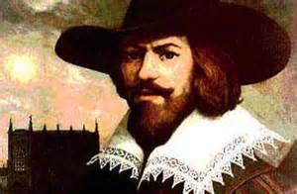
It was November, 1605, and high treason was on the mind of every English subject. A small group of angry Catholics, fed up with ongoing persecution at the hands of the Protestant monarchy, hatched an elaborate plot to blow King James I and his government to smithereens. As luck would have it, a warning letter surfaced at the last minute and James ordered a search of his palace. The most notorious conspirator, Guy Fawkes, was discovered in the cellar, match in hand, ready to ignite twenty barrels of gunpowder "all at one thunderclap."
Shakespeare obviously knew about this plot. These traitors of the realm had some deep connections to Shakespeare and his family: Shakespeare's father, John was known to be a secret Catholic and was friends with William Catesby, the father of the head conspirator, Robert Catesby. Moreover, the Mermaid Tavern in London, owned by one of Shakespeare’s closest friends, was a preferred meeting spot of the traitors as they schemed to obliterate the Protestants once and for all.

Shakespeare felt that he might be under suspicion; he knew some of the people involved, was known to drink where they drank, and his father was a closet Catholic who was close to the conspirators.
While the captured traitors suffered the ultimate punishment of being disembowelled and beheaded in front of the cheering masses, Shakespeare would likely have been only a few miles away, holed up in his estate in Stratford, piecing together tales about different Scottish kings from old history books. Change after change was made until the play became a perfect propaganda machine that seemed to clear Shakespeare of any suspicion.

James’ favourite part of Shakespeare’s new take on history would be the near mythological qualities given to the character created in his image – Macbeth’s victim, King Duncan. While the real Duncan was a war-loving brute, Shakespeare’s Duncan is a thoughtful, infallible, divinely-appointed ruler with “silver skin” and “golden blood.” Killing old Duncan is a calamity of such epic proportion that it sends the kingdom into total chaos and bloodshed.

A master of details, Shakespeare wove direct references to the Gunpowder plot right into Macbeth. To commemorate the discovery of the heinous scheme, King James had a medal created picturing a snake hiding amongst flowers. Unsurprisingly, we find a reference to the medal right in the play when Lady Macbeth tells her husband to look like the innocent flower, but be the serpent under it.

How is the gunpowder plot similar to Macbeth’s plot? (AO3)

______________________________________________________________________________________________________________________________________________________________________________________________________________________________________________________________________________________________________________________________________________________________________________________________________________________________________________________________________________________________________________________________________________________________________________________________________________________________________________________
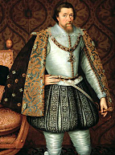  King James Documentary |  | As we watch, you must take notes on the following areas...
Gunpowder Plot |  | King James’ Beliefs
How King James Lost Power |  | Divine Right

Macbeth: Act One
Summary: Act 1, Scene 7
Inside the castle, as servants set a table for the evening’s feast, Macbeth paces by himself, pondering his idea of assassinating Duncan. He says that the deed would be easy if he could be certain that it would not set in motion a series of terrible consequences. He then considers the reasons why he ought not to kill Duncan: Macbeth is Duncan’s kinsman, subject, and host; moreover, the king is universally admired as a virtuous ruler. He faces the fact that there is no reason to kill the king other than his own ambition, which he realizes is an unreliable guide.

Lady Macbeth enters and tells her husband that the king has dined and that he has been asking for Macbeth – who declares that he no longer intends to kill Duncan. Lady Macbeth, outraged, calls him a coward and questions his manhood: “When you durst do it,” she says, “then you were a man”. He asks her what will happen if they fail; she promises that as long as they are bold, they will be successful. Then she tells him her plan: while Duncan sleeps, she will give his chamberlains wine to make them drunk, and then she and Macbeth can slip in and murder Duncan. They will smear the blood of Duncan on the sleeping chamberlains to cast the guilt upon them. He then agrees to proceed with the murder.
Explain Lady Macbeth’s plan in your own words... (AO1)

Act 1, Scene 7: Macbeth’s Castle, Near The Great Hall
How are Macbeth and Lady Macbeth presented here?
Macbeth |  | Lady Macbeth
First, as I am his kinsman and his subject,  Strong both against the deed; then, as his host,  Who should against his murderer shut the door,  Not bear the knife myself. Besides, this Duncan  Hath borne his faculties so meek, hath been  So clear in his great office, that his virtues  Will plead like angels, trumpet-tongued, against  The deep damnation of his taking-off;  And pity, like a naked new-born babe,  Striding the blast, or heaven's cherubim, horsed  Upon the sightless couriers of the air,  Shall blow the horrid deed in every eye,  That tears shall drown the wind. I have no spur  To prick the sides of my intent, but only  Vaulting ambition, which o'erleaps itself  And falls on the other. |  | What beast was't, then,  That made you break this enterprise to me?  When you durst do it, then you were a man;  And, to be more than what you were, you would  Be so much more the man. Nor time nor place  Did then adhere, and yet you would make both:  They have made themselves, and that their fitness now  Does unmake you. I have given suck, and know  How tender 'tis to love the babe that milks me:  I would, while it was smiling in my face,  Have pluck'd my nipple from his boneless gums,  And dash'd the brains out, had I so sworn as you  Have done to this.
What does this show about Macbeth? |  | What does this show about Lady Macbeth?
Annotate your ‘Killer Quotes |  | Annotate your ‘Killer Quotes’
Annotate your ‘Killer Quotes’ |  | Annotate your ‘Killer Quotes’
How are Macbeth and Lady Macbeth presented in Act 1, Scene 7? Bonus points for using ‘chivalry’!
How does the writer achieve it?  Identify a technique/interesting use of language  Use a quote | Why is it effective?  Link to the actual words used  What does it make you feel/do?  What are the connotations?  Does it have an emotional impact? |  | Context  Does it link to Jacobean society, values or beliefs?  Does it link to Machiavellian ideas about power?  How does it relate to women’s role in Jacobean society?
Lit AO1: Use textual references, including quotations, to support and illustrate interpretations. | Lit AO1: Read, understand and respond to texts, maintain a critical style and develop an informed personal response.  Lit AO2: Analyse the language, form and structure used to create meanings and effects, using relevant subject terminology where appropriate. |  | Lit AO3: Show understanding of the relationships between texts and the contexts in which they were written.

Act One Recap
Where is Macbeth set?  - England  - Wales  - Ireland  - Scotland  The characters have returned from a war with which country?  - Greece  - Sweden  - England  - Norway  Complete the simile used to describe Macbeth’s performance in battle: ‘Like Valour’s _________’  - Soldier  - Warrior  - Minion  - Million  What is Macbeth Thane of at the start of the play?  - Scotland  - Glamis  - Fife  - Cawdor  Which characters use the thematic paradox, ‘Fair is foul…’ in Act 1?  - Macbeth and Banquo  - The Weird Sisters  - The Weird Sisters and Macbeth  - The Weird Sisters and Banquo  What prophecy do the sisters give Banquo in Act 1?  - That he will be made Thane of Cawdor  - That his son will be made Thane of Cawdor  - That his sons will be made princes  - That his sons will be made kings  Who do the Macbeths frame for Duncan’s murder?  - Malcolm  - Macduff  - Banquo  - The chamberlains  Where does Malcolm flee to?  - England  - Ireland  - Scotland  - Wales  Why does Lady Macbeth handle the daggers?  - She kills Duncan.  - She kills the chamberlains.  - She frames Macbeth.  - She frames the chamberlains. | Which adjective means cunning and sly?  - Chivalrous.  - Patriarchal.  - Machiavellian.  - Ambitious.  Femininity is…  - The quality of being female.  - The quality of being male.  - Rejecting your womanliness.  - Being a weak man.  A prophecy is…  - Encouragement to do bad things.  - A prediction of the future.  - Encouragement to do good things.  - Interpreting events in the past.  A soliloquy is…  - A release from strong emotions.  - A speech given to the audience.  - A belief in the supernatural.  - Another name for the royal family.  Which adjective describes a social system where men hold the power and influence??  - Maternal.  - Matriarchal.  - Paternal.  - Patriarchal.  What is chivalry?  - Cowardice, diplomacy, courtesy.  - Wicked or criminal behaviour.  - Bravery, military skill, courtesy.  - Unfair, unjust and cruel rule.  What is duplicity?  - A strong desire or wish for someone.  - Deceitfulness or being two-faced.  - Honesty and straight-forwardness.  - Excessive pride or confidence.  Which noun is a worry that you are being persecuted or picked on?  - Cowardice.  - Catharsis.  - Paranoia.  - Tyranny.  Which verb means to take someone’s place illegally or by force?  - Prophesise.  - Tyrannise.  - Usurp.  - Desire.
TRAGIC HERO: great or virtuous character in a dramatic tragedy who is destined for downfall, suffering, or defeat.
HAMARTIA: a fatal flaw.
Ingredients of a tragic hero… | Does Macbeth have these ingredients? Example? (AO1, AO2)
The individual involved has to be a member of upper nobility in order to be a tragic hero.

The tragic hero must have some kind of flaw (hamartia) which might include a mistake in judgment or HUBRIS (pride), the greatest sin of all.

The story must contain some type of obvious reversal. This could be a reversal in attitude or fortune.

Not all tragic heroes die, but all suffer. Sometimes the suffering is mental, sometimes physical, however it is always great suffering.

The tragic hero becomes aware of his situation or plight, but this always comes to the character when it is too late to do anything about the outcome.

The audience must feel these in order for a tragic hero to be real:
- Pity - punishment they received was too great.
- Fear - can see themselves in the hero; it could be me.

Macbeth: Act Two
Summary: Act 2, Scene 1
Banquo explains that although he is tired, he wishes to stay awake because his sleep has lately inspired “cursed thoughts”. Macbeth enters. Banquo says that the king is asleep and mentions that he had a dream about the “three weird sisters.” When Banquo suggests that the es have revealed “some truth” to Macbeth, Macbeth claims that he has not thought of them at all since their encounter in the woods. He and Banquo agree to discuss the witches’ prophecies at a later time.
Banquo and Fleance leave. In the darkened hall, Macbeth has a vision of a dagger floating in the air, its handle pointing toward his hand and its tip aiming him toward Duncan. Macbeth tries to grasp the weapon and fails. He wonders whether what he sees is real or a “dagger of the mind”. He thinks he sees blood on the blade, then abruptly decides that the vision is just a manifestation of his unease over killing Duncan. The night around him seems thick with horror and witchcraft, but Macbeth stiffens and resolves to do his bloody work. A bell tolls—Lady Macbeth’s signal that the chamberlains are asleep—and Macbeth strides toward Duncan’s chamber.

Act 2, Scene 1: Court of Macbeth’s Castle
Is this a dagger which I see before me,
The handle toward my hand? Come, let me clutch thee.
I have thee not, and yet I see thee still.
Art thou not, fatal vision, sensible
To feeling as to sight? or art thou but
A dagger of the mind, a false creation,
Proceeding from the heat-oppressed brain?
I see thee yet, in form as palpable
As this which now I draw.
Thou marshall'st me the way that I was going;
And such an instrument I was to use.
Mine eyes are made the fools o' the other senses,
Or else worth all the rest; I see thee still,
And on thy blade and dudgeon gouts of blood,
Which was not so before. There's no such thing:
It is the bloody business which informs
Thus to mine eyes. [...]
A bell rings
I go, and it is done; the bell invites me.
Hear it not, Duncan; for it is a knell
That summons thee to heaven or to hell.

Summarise what happens in this scene...

‘Hallucinations,’ by Oliver Sacks
“Why Kermit?” asked a woman who started to have hallucinations of the Sesame Street frog many times a day, several weeks after brain surgery. Kermit meant nothing to her, she said, and his shifting moods — sometimes sad, sometimes happy, occasionally angry — had nothing to do with her own feelings.
Such curious apparitions are the subject of Dr. Sacks’ new book, “Hallucinations.” A professor of neurology at the New York School of Medicine, Sacks provides what he calls a kind of “natural history or anthology of hallucinations” drawn experience, his own observations and from literature on the subject.
He describes visual hallucinations, auditory hallucinations, olfactory hallucinations and hallucinations produced by illness, fevers, sleep deprivation, drugs, grief, trauma and exhaustion.
On one occasion, Dr. Sacks says, he injected himself with morphine and spent more than 12 hours staring at the sleeve of his dressing gown, which was hanging on a door. The fabric became alive with a “miniature but microscopically detailed battle scene,” complete with silken tents of different colors, “gaily caparisoned horses, soldiers on horseback, their armor glinting in the sun, and men with longbows.” He had just been reading Shakespeare’s “Henry V,” and he says he realized that he was looking at the Battle of Agincourt, with hundreds, thousands of soldiers preparing to go to war.
While he does not delve into the science of how the brain that can produce such amazing images, Dr. Sacks deftly conveys what it feels like to have such hallucinations — and the place these visions can assume in a person’s emotional and spiritual life.
Although modern Western cultures have tended to regard hallucinations as a sign of “madness or something dire happening to the brain,” Dr. Sacks observes, other cultures regard them, like dreams, “as a special, privileged state of consciousness — one that is actively sought through spiritual practices, meditation, drugs or solitude.”
Many psychical or paranormal experiences, Dr. Sacks suggests, may in fact be hallucinations stemming from bereavement, isolation, sensory deprivation or “drowsy or trancelike states.” Whatever their cause, he says, hallucinatory experiences “generate a world of imaginary beings and abodes — heaven, hell, fairyland.”
In response to physiologically based visions, we create narratives to explain what we’ve seen, and when old-fashioned figures like devils and witches “are no longer believed in, new ones — aliens, visitations from ‘a previous life’ — take their place.”
What explanations does Sacks give for why people hallucinate? (AO1)
Why do you think Macbeth hallucinates? You must explain your answer with references to the play. (AO2, AO3)
Write a short story called ‘The Hallucination’. The cause of your character’s hallucination must be one of those mentioned in the article.

What ‘sign’ convinces Macbeth to kill Duncan?  - An apparition of one of the Weird Sisters  - A nightmare about one of the Weird Sisters  - An apparition of a floating dagger  - The ghost of his dead father visits him | Which verb means to take someone’s place illegally or by force?  - Usurp.  - Prophesise.  - Tyrannise.  - Desire.

Ozymandias
I met a traveller from an antique land
Who said: "Two vast and trunkless legs of stone
Stand in the desert. Near them on the sand,
Half sunk, a shattered visage lies, whose frown
And wrinkled lip and sneer of cold command
Tell that its sculptor well those passions read
Which yet survive, stamped on these lifeless things,
The hand that mocked them and the heart that fed.
And on the pedestal these words appear:
`My name is Ozymandias, King of Kings:
Look on my works, ye mighty, and despair!'
Nothing beside remains. Round the decay
Of that colossal wreck, boundless and bare,
The lone and level sands stretch far away".

Percy Bysshe Shelley

What does Ozymandias teach us about power?

How does the poem relate to the character of Macbeth?

How does the poem relate to King Duncan?

The error in judgement of the tragic hero leads to...  - the audience no longer connecting with the hero  - a reversal of the hero's fortune  - a huge lesson for the hero  - the death of someone close to him  What makes an audience care about and identify with a hero's fate?  - The hero must be attractive  - The hero must be strong and brave  - The hero must be neither better nor worse morally than a 'normal' person  - The hero must possess a strong desire to succeed | What is the name given to the hero's fatal flaw?  - hermertia  - hamartia  - hermian  - hermitia  Hubris is a quality that tragic heroes should possess, according to Aristotle, but what does it mean?  - Fatal flaw  - Reversal of fortune  - Excessive pride  - Good judgement
Macbeth: Act Two
Summary: Act 2, Scene 2
Lady Macbeth imagines Macbeth is killing Duncan. Hearing Macbeth cry out, she worries the chamberlains have woken. She can’t understand how Macbeth could fail—she prepared the daggers herself. She says she’d have killed the king herself “had he not resembled/[her] father as he slept”.
Macbeth emerges, his hands covered in blood, and says that the deed is done. Badly shaken, he remarks that he heard the chamberlains awake and say their prayers before going back to sleep. When they said “amen,” he tried to say it with them but found that the word stuck in his throat. Lady Macbeth becomes angry when she notices that he has forgotten to leave the daggers with the sleeping chamberlains so as to frame them for Duncan’s murder. He refuses to go back into the room, so she takes the daggers into the room herself, saying that she would be ashamed to be as cowardly as Macbeth.
As she leaves, Macbeth hears a mysterious knocking. The portentous sound frightens him, and he asks desperately, “Will all great Neptune’s ocean wash this blood / Clean from my hand?”. Lady Macbeth returns and leads her husband back to the bedchamber, where he can wash off the blood. “A little water clears us of this deed,” she tells him.

Act 2, Scene 2: Court of Macbeth’s Castle
LADY MACBETH
Go get some water,
And wash this filthy witness from your hand.
Why did you bring these daggers from the place?
They must lie there: go carry them; and smear
The sleepy grooms with blood.
MACBETH
I'll go no more:
I am afraid to think what I have done;
Look on't again I dare not.
LADY MACBETH
Infirm of purpose!
Give me the daggers: the sleeping and the dead
Are but as pictures: 'tis the eye of childhood
That fears a painted devil. If he do bleed,
I'll gild the faces of the grooms withal;
For it must seem their guilt.
Exit. Knocking within
MACBETH
Whence is that knocking?
How is't with me, when every noise appals me?
What hands are here? ha! they pluck out mine eyes.
Will all great Neptune's ocean wash this blood
Clean from my hand? No, this my hand will rather
The multitudinous seas in incarnadine,
Making the green one red.
Re-enter LADY MACBETH
LADY MACBETH
My hands are of your colour; but I shame
To wear a heart so white.

Who is the more powerful character
in Act Two, Scene Two?
How does Macbeth act in this scene? |  |  |  | How does Lady Macbeth act in this scene?
Choose a quote to support this and annotate it. |  |  |  | Choose a quote to support this and annotate it.
Choose a supporting quote and annotate it. |  |  |  | Choose a supporting quote and annotate it.
Who is the more powerful character in Act Two, Scene Two?
How does the writer achieve it?  Identify a technique/interesting use of language  Use a quote |  | Why is it effective?  Link to the actual words used  What does it make you feel/do?  What are the connotations?  Does it have an emotional impact? |  |  | Context  Does it link to Jacobean society, values or beliefs?  Does it link to Machiavellian ideas about power?  How does it relate to women’s role in Jacobean society?
Lit AO1: Use textual references, including quotations, to support and illustrate interpretations. |  | Lit AO1: Read, understand and respond to texts, maintain a critical style and develop an informed personal response.  Lit AO2: Analyse the language, form and structure used to create meanings and effects, using relevant subject terminology where appropriate. |  |  | Lit AO3: Show understanding of the relationships between texts and the contexts in which they were written.
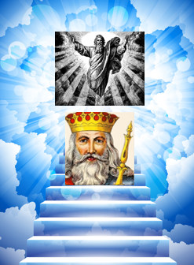
Opinions on Royalty in 1600s
The King or Queen in Shakespeare’s time were considered to be a step down from God. It was believed that God spoke to the monarch. The monarch was the leader, protector, father/mother and the route to heaven. Love and obey your monarch and you will go to heaven. Defy or betray your monarch (TREASON) or kill a king (REGICIDE) and you are killing a God, and you’ll surely go to Hell.

Punishment for Treason
You would be branded a traitor. In Dante’s Inferno (famous pre Macbeth poem) the lowest circle of Hell was reserved for traitors. If you were caught your execution would see you hanged, drawn and quartered. This consisted of hanging till almost dead, then your insides pulled out and your body cut into four pieces. Unless you were a woman, in which case you’d be burnt at the stake.
Question One: How does this view of the monarchy affect Macbeth?
Question Two: With this in mind, why are Lady Macbeth’s actions so surprising?
1st Circle | Limbo |  |  | The unbaptised and virtuous pagans were kept between heaven and hell.
2nd Circle | Lust |  |  | Souls are blown about in a violent storm without hope of rest.
3rd Circle | Gluttony |  |  | Gluttons are forced to lie in vile, freezing slush forever.
4th Circle | Avarice and Prodigality |  |  | The miserly and spendthrifts push great weights together, crashing them time and again.
5th Circle | Wrath and Sullenness |  |  | The wrathful fight each on the surface of the river Styx while the sullen gurgle beneath it.
6th Circle | Heresy |  |  | Heretics are trapped in flaming tombs for eternity.
7th Circle | Violence |  |  | The violent against people and property, the suicides and the blasphemers.
8th Circle | Fraud |  |  | Liars, thieves, flatterers, false prophets, sorcerers and seducers.
9th Circle | Treachery/Treason |  |  | Betrayers of special relationships are frozen in a lake of ice.
Look up any of the sins/crimes you are unfamiliar with. Add their definitions.
Which crimes have the couple committed? Find evidence to show this. Which circle of hell do they belong in at this point in the story?

Macbeth: Act Two
Summary: Act 2, Scene 3
A porter stumbles through the hallway to answer the knocking. Macduff and Lennox enter, and Macduff complains about the porter’s slow response. The porter says that he was up late and rambles on about the effects of alcohol. Macbeth enters, and Macduff asks him if the king is awake, saying Duncan asked to see him early that morning. Macbeth says Duncan is still asleep and offers to take Macduff to him. As Macduff enters the king’s chamber, Lennox describes the terrible storms that raged the previous night. With a cry of “O horror, horror, horror!” Macduff comes running from the room, shouting that the king has been murdered. Macbeth and Lennox rush in to look, while Lady Macbeth appears and expresses her horror that such a deed could be done under her roof. The king’s sons, Malcolm and Donalbain, arrive. They are told that their father has been killed, most likely by his chamberlains, who were found with bloody daggers. Macbeth declares that in his rage he has killed the chamberlains.
Macduff seems suspicious of these new deaths, which Macbeth explains by saying that his fury at Duncan’s death was so powerful that he could not restrain himself. Lady Macbeth suddenly faints, and both Macduff and Banquo call for someone to attend to her. Malcolm and Donalbain whisper to each other that they are not safe, since whoever killed their father will probably kill them next. Lady Macbeth is taken away, while Banquo and Macbeth rally the lords to meet and discuss the murder. Duncan’s sons decide to flee. Malcolm says he will go to England, and Donalbain will go to Ireland.

Act 2, Scene 3: The Entrance to Macbeth’s Castle
MACDUFF
Your royal father 's murder'd. [...]
LENNOX
Those of his chamber, as it seem'd, had done 't:
Their hands and faces were an badged with blood;
So were their daggers, which unwiped we found
Upon their pillows:
MACBETH
O, yet I do repent me of my fury,
That I did kill them.
MACDUFF
Wherefore did you so?
MACBETH
Who can be wise, amazed, temperate and furious,
Loyal and neutral, in a moment? No man:
The expedition my violent love
Outrun the pauser, reason. Here lay Duncan,
His silver skin laced with his golden blood;
And his gash'd stabs look'd like a breach in nature
For ruin's wasteful entrance: there, the murderers,
Steep'd in the colours of their trade, their daggers
Unmannerly breech'd with gore: who could refrain,
That had a heart to love, and in that heart
Courage to make's love known?
Do you think Macbeth believes his own lies? (AO2)
______________________________________________________________________________________________________________________________________________________________________________________________________________________________________________________________________________________________________________________________________________________________________________________________________________________________________________________________________________________________________________________________________________________________________________________________________________________________________________________

Macbeth: Act Two
Summary: Act 2, Scene 4
Ross, a thane, walks outside the castle with an old man. They discuss the strange and ominous happenings of the past few days: it is daytime, but dark outside; last Tuesday, an owl killed a falcon; and Duncan’s beautiful, well-trained horses behaved wildly and ate one another. Macduff emerges from the castle and tells Ross that Macbeth has been made king by the other lords, and that he now rides to Scone to be crowned. Macduff adds that the chamberlains seem the most likely murderers, and that they may have been paid off by someone to kill Duncan. Suspicion has now fallen on the two princes, Malcolm and Donalbain, because they have fled the scene. Macduff returns to his home at Fife, and Ross departs for Scone to see Macbeth’s coronation as the new king.
What ‘sign’ convinces Macbeth to kill Duncan?  - An apparition of one of the Weird Sisters  - A nightmare about one of the Weird Sisters  - An apparition of a floating dagger  - The ghost of his dead father visits him  What reason does Macbeth give for why he should not commit regicide?  - Banquo’s sons will be king anyway, so he will clearly not be king for long  - Duncan is a good man and a noble leader  - Duncan is too good looking  - Banquo will know he has killed the king  Why didn’t Lady Macbeth just kill the king herself?  - She believed that Macbeth needed to prove he was a man  - Duncan looked too much like her father  - She didn’t agree with murder  - She felt she didn’t have the bodily strength as a woman  What does Macbeth accidentally take with him after murdering the king?  - The murder weapons  - The king’s crown  - The bible  - The King’s bloody pillow | Name the speaker: ‘My hands are of your colour- but I shame to wear a heart so white!’  - The Old Man  - Macbeth  - Lady Macbeth  - Banquo  Who else does Macbeth kill?  - The chamberlains  - Banquo  - Lennox  - Fleance  Which characters run away shortly after Duncan’s death?  - Banquo and Fleance  - Macbeth and Lady Macbeth  - Malcolm and Donalbain  - Macduff and his family  ‘Regicide’ is murder of a _______.  - Thane  - Monarch  - Brother  - Knight  At whose house is Duncan found dead?  - His palace  - Macbeth’s  - Banquo’s  - Macduff’s

Macbeth: Act Three
Summary: Act 3, Scene 1
In the royal palace at Forres, Banquo thinks about the coronation of Macbeth and the prophecies of the weird sisters. They foretold Macbeth would be king and that Banquo’s line would eventually sit on the throne. If the first prophecy came true, Banquo thinks, why not the second? Macbeth enters, dressed as king. He is followed by Lady Macbeth, and the court. They ask Banquo to attend a feast they will host that night. Banquo accepts and says he plans to go for a ride on his horse for the afternoon. Macbeth says they should discuss the problem of Malcolm and Donalbain. The brothers have fled from Scotland and may be plotting against his crown.
Banquo departs, and Macbeth is left alone in the hall with a single servant, to whom he speaks about some men who have come to see him. Once the servant has gone to get them, Macbeth begins a soliloquy. He muses on Banquo, reflecting that his old friend is the only man in Scotland he fears. He notes that if the witches’ prophecy is true, his will be a “fruitless crown,” by which he means that he will not have an heir. The murder of Duncan, which weighs so heavily on his conscience, may have simply cleared the way for Banquo’s sons to overthrow Macbeth’s own family.
The servant returns with the two visitors. Macbeth reminds the two men, who are hired murderers, of a conversation he had with them the day before, in which he told of the wrongs Banquo had done them in the past. He asks if they are angry and manly enough to take revenge on Banquo. They reply that they are, and Macbeth accepts their promise that they will murder his former friend and his son, Fleance.

Act 3, Scene 1: The Palace, Forres
BANQUO
Thou hast it now: king, Cawdor, Glamis, all,
As the weird women promised, and, I fear,
Thou play'dst most foully for't: yet it was said
It should not stand in thy posterity,
But that myself should be the root and father
Of many kings. If there come truth from them--
As upon thee, Macbeth, their speeches shine--
Why, by the verities on thee made good,
May they not be my oracles as well,
And set me up in hope? But hush! no more.
Re-write Banquo’s speech in modern English...
__________________________________________________________________________________________________________________________________________________________________________________________________________________________________________________________________________________________________________________________________________________________________________________________________________________________________________________________________________________________________________________________________________________________________________________________________________________________________________________________________________________________________________________________________________________________________________________________________
What is paranoia?
Everybody experiences suspicious or irrational thoughts from time to time. These fears are described as paranoid when they are exaggerated and there is no evidence that they are true.
There are three key features of paranoid thoughts. If you have paranoia, you may:
- fear that something bad will happen
- think that other people or external causes are responsible
- have beliefs that are exaggerated or unfounded.
Generally speaking, if you are experiencing paranoia, you will feel a sense of threat and fear.
MACBETH
Our fears in Banquo
Stick deep; and in his royalty of nature
Reigns that which would be fear'd: 'tis much he dares;
And, to that dauntless temper of his mind,
He hath a wisdom that doth guide his valour
To act in safety. There is none but he
Whose being I do fear: and, under him,
My Genius is rebuked; as, it is said,
Mark Antony's was by Caesar. He chid the sisters
When first they put the name of king upon me,
And bade them speak to him: then prophet-like
They hail'd him father to a line of kings:
Upon my head they placed a fruitless crown,
And put a barren sceptre in my gripe,
Thence to be wrench'd with an unlineal hand,
No son of mine succeeding. If 't be so,
For Banquo's issue have I filed my mind;
For them the gracious Duncan have I murder'd;
Put rancours in the vessel of my peace
Only for them; and mine eternal jewel
Given to the common enemy of man,
To make them kings, the seed of Banquo kings!
Rather than so, come fate into the list.
And champion me to the utterance!
Is Macbeth paranoid?
How does the writer achieve it?  Identify a technique/interesting use of language  Use a quote | Why is it effective?  Link to the actual words used  What does it make you feel/do?  What are the connotations?  Does it have an emotional impact? |  | Context  Does it link to Jacobean society, values or beliefs?  Does it link to Machiavellian ideas about power?  How does it relate what you’ve learned about hallucination?
Lit AO1: Use textual references, including quotations, to support and illustrate interpretations. | Lit AO1: Read, understand and respond to texts, maintain a critical style and develop an informed personal response.  Lit AO2: Analyse the language, form and structure used to create meanings and effects, using relevant subject terminology where appropriate. |  | Lit AO3: Show understanding of the relationships between texts and the contexts in which they were written.

Macbeth: Act Three
Summary: Act 3, Scene 2
Elsewhere in the castle, Lady Macbeth expresses despair and sends a servant to fetch her husband. Macbeth enters and tells his wife that he too is discontented, saying that his mind is “full of scorpions”. He feels that the business that they began by killing Duncan is not yet complete because there are still threats to the throne that must be eliminated. Macbeth tells his wife that he has planned “a deed of dreadful note” for Banquo and Fleance and urges her to be jovial and kind to Banquo during the evening’s feast, in order to lure their next victim into a false sense of security.

Act 3, Scene 2: A Room in Macbeth’s Palace
MACBETH
O, full of scorpions is my mind, dear wife!
Thou know'st that Banquo, and his Fleance, lives. […]
LADY MACBETH
What's to be done?
MACBETH
Be innocent of the knowledge, dearest chuck,
Till thou applaud the deed. Come, seeling night,
Scarf up the tender eye of pitiful day;
And with thy bloody and invisible hand
Cancel and tear to pieces that great bond
Which keeps me pale! Light thickens; and the crow
Makes wing to the rooky wood:
Good things of day begin to droop and drowse;
While night's black agents to their preys do rouse.
Thou marvell'st at my words: but hold thee still;
Things bad begun make strong themselves by ill.

Explore you feel about Macbeth at this stage?
- Are you on his side?
- Do you want him to succeed?
- Would you do what he has done?
- Answer on lined paper.
- Your answer must include at least two quotations.

What does Macbeth hire men to do?  - Protect him from assassins  - Kill Macduff and his family  - Find the witches so he can talk to them again  - Kill Banquo and his son  What does a ‘fruitless crown’ mean?  - No heirs  - A lot of battles  - No queen  - A poor king | Macbeth says his mind is full of….  - Nightmares  - Ghosts  - Witches  - Scorpions  What is original sin?  - A speech given to the audience.  - A release from strong emotions.  - A belief in the supernatural.  - Another name for the royal family.
Macbeth: Act Three
Summary: Act 3, Scene 3
It is dusk, and the two murderers, now joined by a third, linger in a wooded park outside the palace. Banquo and Fleance approach on their horses and dismount. They light a torch, and the murderers set upon them. The murderers kill Banquo, who dies urging his son to flee and to avenge his death. One of the murderers extinguishes the torch, and in the darkness Fleance escapes. The murderers leave with Banquo’s body to find Macbeth and tell him what has happened.

Act 3, Scene 3: A Lonely Place Near Forres
Enter BANQUO, and FLEANCE with a torch
Third Murderer
'Tis he.
First Murderer
Stand to't.
BANQUO
It will be rain to-night.
First Murderer
Let it come down.
They set upon BANQUO
BANQUO
O, treachery! Fly, good Fleance, fly, fly, fly!
Thou mayst revenge. O slave!
Dies. FLEANCE escapes
Third Murderer
Who did strike out the light?
First Murderer
Wast not the way?
Third Murderer
There's but one down; the son is fled.
Second Murderer
We have lost
Best half of our affair.
First Murderer
Well, let's away, and say how much is done.

Skim back through the play so far. Search for as many quotes as you can which show Banquo to be a character who does not deserve to die... (AO1)

We send our soldiers to witness the horror of war but, when they return, we ignore them.
Is there anything so sad as an old man in tears? Private Holland had never been further than the Manchester Ship Canal when he went off to Malaya, to fight in the jungle. He shot people, ran over a man who had his hands up, saw his own friends die next to him. And he's been haunted ever since, reliving it all in his bed every night. He's 78 now.

Guardsman Tromans is good at describing the fear. It's like a car crash, or when you're being mugged, "and you get that feeling for a split second when you don't know what's going to happen to you. If you can imagine that feeling 24 hours a day, seven days a week - that's what it felt like to be there." For Tromans, "there" was Iraq, this time round. He's on the dole now, and drugs, in and out of trouble.
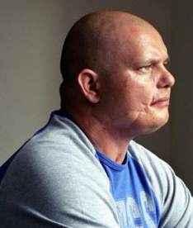
And here's Fusilier Beddoes, with one half of his face in shadow to hide the scars where the bullet went in. He was in the Balkans. Peace-keeping they called it, but the men in the blue hats had to sit by and watch, unable to do anything as the death squads went on their daily killing sprees. The peace-keepers had to deal with the aftermath - men, women and children, killed. Beddoes, back home now, shouts at his own children and wife. But she still stands by him, she understands, even if the country doesn't. It means her husband cares. "It's the people who don't care - they're the ones who are scary," she says.

These are Forgotten Heroes: The Not Dead, men who came back from war and went off the rails - "big time" says Tromans.

There are hundreds of them: more Falklands veterans have killed themselves since 1982 than died in the South Atlantic. That's just one shocking statistic. The survivors are largely ignored - though not, thankfully, by film-maker Brian Hill and poet Simon Armitage, whose wonderful work this is.

It's bold, brave, beautiful television; it makes you think, and it leaves you numb.

Remains by Simon Armitage
On another occasion, we get sent out  to tackle looters raiding a bank.  And one of them legs it up the road,  probably armed, possibly not.  Well myself and somebody else and somebody else  are all of the same mind,  so all three of us open fire.  Three of a kind all letting fly, and i swear  I see every round as it rips through his life -  I see broad daylight on the other side.  So we’ve hit this looter a dozen times  and he’s there on the ground, sort of inside out,  pain itself, the image of agony.  One of my mates goes by  and tosses his guts back into his body.  Then he’s carted off in the back of a lorry. | End of story, except not really.  His blood-shadow stays on the street, and out on patrol  I walk right over it week after week.  Then I’m home on leave. But I blink  and he bursts again through the door of the bank.  Sleep, and he’s probably armed, possibly not.  Dream, and he’s torn apart by a dozen rounds.  And the drink and the drugs won’t flush him out.  He’s here in my head when I close my eyes,  dug in behind enemy lines,  not left for dead in some distant, sun-stunned, sand-smothered land  or six-feet-under in desert sand,  but near to the knuckle, here and now,  his bloody life in my bloody hands.

What are the symptoms?

The symptoms of PTSD can vary from person to person, although you may experience some of the following.

Reliving aspects of the trauma:  - Vivid flashbacks (feeling that the trauma is happening all over again).  - Intrusive thoughts and images.  - Nightmares.  - Intense distress at real or symbolic reminders of the trauma.  - Physical sensations, such as pain, sweating, nausea or trembling.  Avoiding feelings or memories:  - Avoiding situations that remind you of the trauma.  - Repressing memories (being unable to remember aspects of the event).  - Feeling detached, cut off and emotionally numb.  - Being unable to express affection. | Alertness or feeling on edge:  - Panicking when reminded of the trauma.  - Being easily upset or angry.  - Extreme alertness.  - A lack of or disturbed sleep.  - Irritability and aggressive behaviour.  - Lack of concentration.  - Being easily startled.  - Self-destructive behaviour or recklessness.  You may also develop other mental health problems, such as:  - Severe anxiety.  - A phobia.  - Depression.  - A dissociative disorder.  - Suicidal feelings.
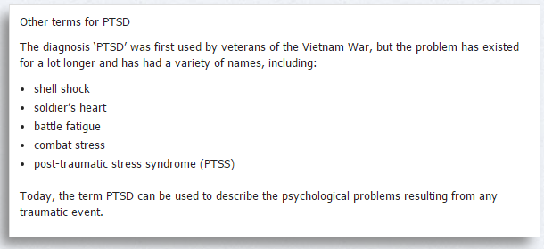

Is Macbeth suffering PTSD? Give evidence for your answer, providing symptoms and quotations to support your theory.
Compare the way Armitage presents PTSD in Remains with the way Macbeth behaves after killing Duncan.
Extension: could you argue that Lady Macbeth is also suffering PTSD? Explain with quotations.
Macbeth: Act Three
Summary: Act 3, Scene 4
Macbeth and Lady Macbeth enter the feast. As Macbeth walks among the court, the first murderer appears at the doorway. Macbeth speaks to him, learning that Banquo is dead and Fleance has escaped. The news of Fleance’s escape angers Macbeth—if only Fleance had died, his throne would have been secure. Instead, “the worm that’s fled / Hath nature that in time will venom breed”. Returning to his guests, Macbeth goes to sit at the head of the table but finds Banquo’s ghost sitting in his chair. Horror-struck, Macbeth speaks to the ghost, which is invisible to the rest of the company. Lady Macbeth makes excuses for her husband, saying that he occasionally has such “visions” and that the guests should simply ignore his behaviour. The ghost disappears, and Macbeth recovers. As he offers a toast to company, however, Banquo’s ghost reappears and shocks Macbeth into further outbursts. Continuing to make excuses for her husband, Lady Macbeth sends the alarmed guests out of the room as the ghost vanishes again. Macbeth mutters that “blood will have blood” and tells Lady Macbeth that he has heard from a servant-spy that Macduff intends to keep away from court. He says he will visit the witches again tomorrow in the hopes of learning more about the future and about who may be plotting against him. He resolves to do whatever is necessary to keep his throne.

Act 3, Scene 4: The Banqueting Hall at Forres
MACBETH
It will have blood; they say, blood will have blood: [...]
I am in blood
Stepp'd in so far that, should I wade no more,
Returning were as tedious as go o'er [...]
LADY MACBETH
You lack the season of all natures, sleep.
MACBETH
Come, we'll to sleep. My strange and self-abuse
Is the initiate fear that wants hard use:
We are yet but young in deed.
Tracking blood imagery in Macbeth: re-read the play so far, and make a note of quotations featuring blood…
Macbeth: Act Three
Summary: Act 3, Scene 5
Upon the stormy heath, the witches meet with Hecate, the goddess of witchcraft. Hecate scolds them for meddling in the business of Macbeth without consulting her but declares that she will take over as supervisor of the mischief. She says that when Macbeth comes the next day, as they know he will, they must summon visions and spirits whose messages will fill him with a false sense of security and “draw him on to his confusion”. Hecate vanishes, and the witches go to prepare their charms.
Many people believe that Shakespeare did not actually write this scene and it was inserted at a later date, so we will not dwell on it here.

Recap the story so far...
What does Macbeth hire men to do?  - Protect him from assassins.  - Kill Macduff and his family.  - Kill Banquo and his son.  - Find the witches so he can talk to them again.  What does Banquo wonder about the witches’ prophecy?  - If there is any room for free will in the world or if all is fate.  - If his descendants will really become kings.  - If perhaps they were wrong and he might become king one day.  - If he could bribe or threaten them into changing the future.  Where is Banquo supposed to be on the night he is murdered?  - At home.  - In battle.  - At the banquet.  - On the battlements.  What does a ‘fruitless crown’ mean?  - No heirs.  - A lot of battles.  - No queen.  - A poor king.  Macbeth says his mind is full of….  - Nightmares.  - Ghosts.  - Witches.  - Scorpions.  What change is there in Macbeth and Lady Macbeth’s relationship?  - Lady Macbeth is no longer needed to persuade Macbeth to kill.  - They are more in love than ever.  - Lady Macbeth is the driving force behind Macbeth’s ambition.  - Lady Macbeth motivates Macbeth to carry on killing. | How does Macbeth feel about Banquo?  - He fears that Banquo and his sons will cut short his reign.  - He believes Banquo to be a loyal friend.  - He thinks Banquo is planning on murdering him.  - In his madness, he forgets who Banquo is.  Does Lady Macbeth think this murder of Banquo and his son is necessary?  - No, but she will help him if he does kill them.  - Yes, she thinks the business won’t be done until they are both dead.  - She’s indecisive about it.  - She opposes it and threatens to stop Macbeth if he does.  What word best describes Macbeth at this stage?  - Tyrannical.  - Dramatic.  - Valiant.  - Proud.  What is duplicity?  - A strong desire or wish for someone.  - Deceitfulness or being two-faced.  - Honesty and straight-forwardness.  - Excessive pride or confidence.  Which verb means to take someone’s place illegally or by force?  - Tyrannise.  - Desire.  - Usurp.  - Prophesise.  Tyranny is…  - A belief in the supernatural.  - A serious disagreement or argument.  - Wicked or criminal behaviour.  - An unfair, unjust or cruel governance.

Macbeth: Act Three
Summary: Act 3, Scene 6
That night, somewhere in Scotland, Lennox walks with another lord, discussing what has happened to the kingdom. Banquo’s murder has been officially blamed on Fleance, who has fled. Nevertheless, both men suspect Macbeth, whom they call a “tyrant,” in the murders of Duncan and Banquo. The lord tells Lennox that Macduff has gone to England, where he will join Malcolm in pleading with England’s King Edward for aid. News of these plots has prompted Macbeth to prepare for war. Lennox and the lord express their hope that Malcolm and Macduff will be successful and that their actions can save Scotland from Macbeth.

tyrant (noun)
- A cruel and oppressive ruler who controls his country with absolute power and is not restricted by law.
"the tyrant ruled his people cruelly”
“an evil tyrant who has opposed all who oppose him”
synonyms: dictator; despot; autocrat; absolute ruler; authoritarian; oppressor
Real Life Tyrants
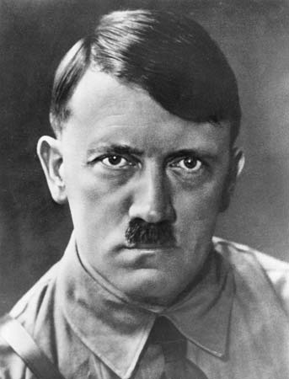 | Adolf Hitler--Nazi dictator of Germany (1933-1945) who originally took office through the German electoral system but quickly threw out the constitution and ruled through force. Responsible for millions of deaths by starting the European portion of World War Two and through the Holocaust, which was an attempt to destroy all Jews in Europe.
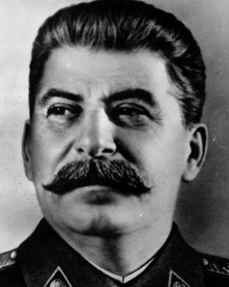 | Joseph Stalin--Soviet dictator (1924-1953). Stalin was a totalitarian ruler, and stayed in power by removing and murdering anyone he thought might be a threat to him. His ideas and policies turned the Soviet Union into a powerful, modern nation, the largest on Earth. It also led to the deaths of millions of people – perhaps as many as 60 million Russians died under his rule.
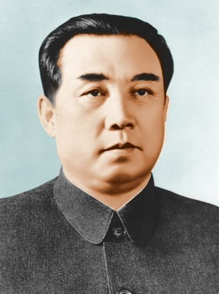 | Kim Jong-Il--Communist dictator of North Korea (1994-2011) Attempted to set up one of his sons to inherit the country upon his passing. Under Jong-Il, North Korea developed nuclear weapons and engaged in dangerous nuclear diplomacy with the U.S, and has engaged in military attacks on South Korea, including the bloody attack on Yeonpyeong Island in 2010.
Is Macbeth really a tyrant? You must support your answer with evidence from the text...
Macbeth: Act Four
Summary: Act 4, Scene 1
In a dark cavern, a bubbling cauldron hisses and spits, and the three witches suddenly appear onstage. They circle the cauldron, chanting spells and adding bizarre ingredients to their stew. Macbeth enters. He asks the witches to reveal the truth of their prophecies to him. To answer his questions, they summon horrible apparitions, each of which offers a prediction to allay Macbeth’s fears. First, a floating head warns him to beware Macduff; Macbeth says that he has already guessed as much. Then a bloody child appears and tells him that “none of woman born/shall harm Macbeth”. Next, a crowned child holding a tree tells him that he is safe until Birnam Wood moves to Dunsinane Hill. Finally, a procession of eight crowned kings walks by, the last carrying a mirror. Banquo’s ghost walks at the end of the line. Macbeth demands to know the meaning of this final vision, but the witches vanish. Lennox enters and tells Macbeth that Macduff has fled to England. Macbeth resolves to send murderers to capture Macduff’s castle and to kill Macduff’s wife and children.

Act 4, Scene 1: A Desolate Place Near Forres
First Witch
Thrice the brinded cat hath mew'd.
Second Witch
Thrice and once the hedge-pig whined.
Third Witch
Harpier cries 'Tis time, 'tis time.
First Witch
Round about the cauldron go;
In the poison'd entrails throw.
Toad, that under cold stone
Days and nights has thirty-one
Swelter'd venom sleeping got,
Boil thou first i' the charmed pot.
ALL
Double, double toil and trouble;
Fire burn, and cauldron bubble.
Second Witch
Fillet of a fenny snake,
In the cauldron boil and bake;
Eye of newt and toe of frog,
Wool of bat and tongue of dog,
Adder's fork and blind-worm's sting,
Lizard's leg and owlet's wing,
For a charm of powerful trouble,
Like a hell-broth boil and bubble.
ALL
Double, double toil and trouble;
Fire burn and cauldron bubble.
Third Witch
Scale of dragon, tooth of wolf,
Witches' mummy, maw and gulf
Of the ravin'd salt-sea shark,
Root of hemlock digg'd i' the dark,
Liver of blaspheming Jew,
Gall of goat, and slips of yew
Silver'd in the moon's eclipse,
Nose of Turk and Tartar's lips,
Finger of birth-strangled babe
Ditch-deliver'd by a drab,
Make the gruel thick and slab:
Add thereto a tiger's chaudron,
For the ingredients of our cauldron.
ALL
Double, double toil and trouble;
Fire burn and cauldron bubble.
Second Witch
Cool it with a baboon's blood,
Then the charm is firm and good.
[...] Second Witch
By the pricking of my thumbs,
Something wicked this way comes.

PLOSIVES  Plosives are the sounds /d/ /b/ /p/ /t/ /k/ at the start of words. They are consonants in which the vocal tract is blocked so that all airflow stops.  ‘Double double toil and trouble  Fire burn and cauldron bubble’  Tasks  - Annotate your scene looking for examples  - Say these words aloud. They’re quite aggressive. Why would Shakespeare choose these sounds for the witches? |  | FRICATIVES  Fricatives are the sounds [s], [z], [ʃ] and [ʒ] which produce a hissing sound when pronounced.  [s] as in sausage [ʒ]as in vision  [z] as in buzz [ʃ] as in ship  ‘Sweltered venom, sleeping got’  Tasks  - Annotate your scene looking for examples  - Say these words aloud. They produce a snake-like hissing sound. Why would Shakespeare choose these sounds for the witches?
SEMANTIC FIELD OF DEATH  A semantic field is a group of words which are associated in some way to one another. The Witches use a semantic field of death and dying throughout their speech.  Tasks  - Annotate your scene looking for examples  - Why do you think Shakespeare put a semantic field of death in the speech of the witches? |  | SEMANTIC FIELD OF NATURE  A semantic field is a group of words which are associated in some way to one another. The Witches use a semantic field of nature and animals throughout their speech.  Tasks  - Annotate your scene looking for examples  - Why do you think Shakespeare put a semantic field of nature and animals in the speech of the witches?  - What kind of animals are included (cold blooded or warm blooded or both?) Why these animals? What associations do they have?
Act 1, Scene 3 | Act 4, Scene 1
Where do the witches first appear to Macbeth?  Place:  Time:  Weather: | What is the setting when Macbeth sees the witches for the second time?  Place:  Time:  Weather:
What predictions do they make about Macbeth?  1.  2.  What do they say about Banquo and his sons?  1.  2. | What do they say about Macbeth’s death?  1.  2.  Who should Macbeth ‘beware’?  What raises Macbeth’s confidence?
How confident does Macbeth feel after the second prophecies?
__________________________________________________________________________________________________________________________________________________________________________________________________________________________________________________________________________________________________________________________________________________________________________________________________________________________________________________________________________________________________________________________________________________________________________________________________________________________________________________________________________________________________________________________________________________________________________________________________________________________________________________________________________________________________________________________________________________________________________________________________________________________________________________________________________________________________________________________________________________________________________________________________________________________________________________________________________________________________________________________________________________________________________________
Macbeth: Act Four
Summary: Act 4, Scene 2
At Macduff’s castle, Lady Macduff accosts Ross, demanding to know why her husband has fled. She feels betrayed. Ross insists that she trust her husband’s judgment and then regretfully departs. Once he is gone, Lady Macduff tells her son that his father is dead, but the little boy perceptively argues that he is not. Suddenly, a messenger hurries in, warning Lady Macduff that she is in danger and urging her to flee. Lady Macduff protests, arguing that she has done no wrong. A group of murderers then enters. When one of them denounces Macduff, Macduff’s son calls the murderer a liar, and the murderer stabs him. Lady Macduff turns and runs, and the pack of killers chases after her.

A Jacobean woman was expected to aspire to be...  - thin and attractive  - subordinate to her husband  - a mother  - a strong character | Which word describes the male-dominated society of Jacobean England?  - matriarchal  - maternal  - patriarchal  - paternal
Macduff has fled to England to raise enough forces to overthrow the increasingly murderous Macbeth. However, in doing so he has left his wife and family behind – and they are now at risk themselves.
Lady Macduff tells her sons that he father is “dead” and a “traitor”. She seems to want to remove him from their lives, perhaps to protect her son. But the boy continues to intelligently question the truth of what she says.
As a class, debate Macduff’s actions. Should he have stayed and protected his family (which might lead to many more people being killed by Macbeth)? Or was he right to act as he did? Should our first sense of duty be to ourselves, our loved ones or our country?

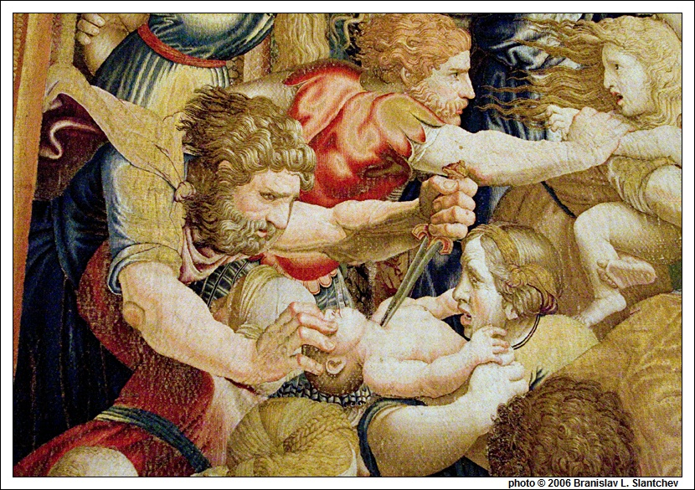
This picture is of Herod’s slaughter of the innocents, a mass infanticide in the Bible. Why is the killing of children so emotive?
Macbeth: Act Four
Summary: Act 4, Scene 3
Outside King Edward’s palace, Malcolm speaks with Macduff, telling him that he does not trust him since he has left his family in Scotland and may be secretly working for Macbeth. To determine whether Macduff is trustworthy, Malcolm rambles on about his own vices. He admits that he wonders whether he is fit to be king, since he claims to be lustful, greedy, and violent. At first, Macduff politely disagrees with his future king, but eventually Macduff cannot keep himself from crying out, “O Scotland, Scotland!”. Macduff’s loyalty to Scotland leads him to agree that Malcolm is not fit to govern Scotland and perhaps not even to live. In giving voice to his disparagement, Macduff has passed Malcolm’s test of loyalty. Malcolm then retracts the lies he has put forth about his supposed shortcomings and embraces Macduff as an ally. A doctor appears briefly and mentions that a “crew of wretched souls” waits for King Edward so they may be cured. When the doctor leaves, Malcolm explains to Macduff that King Edward has a miraculous power to cure disease.
Ross enters. He has just arrived from Scotland, and tells Macduff that his wife and children are well. He urges Malcolm to return to his country, listing the woes that have befallen Scotland since Macbeth took the crown. Malcolm says that he will return with ten thousand soldiers lent him by the English king. Then, breaking down, Ross confesses to Macduff that Macbeth has murdered his wife and children. Macduff is crushed with grief. Malcolm urges him to turn his grief to anger, and Macduff assures him that he will inflict revenge upon Macbeth.

Act 4, Scene 3: England – The Palace of King Edward
ROSS
[...] I have words
That would be howl'd out in the desert air,
Where hearing should not latch them.
MACDUFF
[...] Keep it not from me, quickly let me have it.
ROSS
Let not your ears despise my tongue for ever,
Which shall possess them with the heaviest sound
That ever yet they heard. [...]
Your castle is surprised; your wife and babes
Savagely slaughter'd: to relate the manner,
Were, on the quarry of these murder'd deer,
To add the death of you. [...]
MACDUFF
My children too?
ROSS
Wife, children, servants, all
That could be found.
MACDUFF
He has no children. All my pretty ones?
Did you say all? O hell-kite! All?

Which is the worse crime: murdering King Duncan or having Macduff’s family slaughtered? Things to consider: who did the deed; who were the victims; what were the motives; regicide vs infanticide; motive.

Recap the story so far...
The second witch says, ‘By the pricking my thumbs, something wicked this way comes.’ Who comes?  - Macduff.  - Macbeth.  - Banquo’s ghost.  - Duncan.  What is Macbeth’s attitude towards the sisters this time?  - Trying to take charge.  - Trying to ask for visions.  - Trying to take a poison.  - Trying to ask for advice.  What four things did the witches show Macbeth?  - An armed head, a bloody child, a crowned child with a tree in his hand, eight kings followed by Banquo’s ghost with a mirror.  - Armed head, visions, crowned child with a tree in his hand and a battlefield.  - A head, a blood child, a crown and a cake.  - An armed child, a bloody child, a crowned child with a tree in his hand, eight kings followed by Banquo’s ghost with a mirror.  Macbeth says of the witches, ‘Infected be the air whereon they ride, And damned all those that trust them!’ What is Macbeth saying about himself?  - He is injured.  - He is crazy.  - He is thinking about the death of Malcolm and Macduff.  - He is damned.  Where is Macduff?  A. In the palace preparing.  B. In Ireland, helping Malcolm raise an army.  C. In Norway, helping Malcolm raise an army.  D. In England, helping Malcolm raise an army.  In Malcolm's line: 'Angels are still bright, though the brightest fell. Though all things foul would wear the brows of grace, Yet grace must still look so', who is the 'brightest angel'?  - Gabriel  - Satan  - Raphael  - Jesus  In the above line, the 'brightest angel fell' is a metaphor for whose fate?  A. Macduff.  B. Banquo.  C. Duncan.  D. Macbeth |  | Why does Macbeth have Macduff's family and servants killed?  - Macduff is not loyal and Macbeth wants to kill his family as they could kill him.  - Macduff is not loyal to Macbeth, and Macbeth is angry.  - Macduff is angry with Macbeth and he is afraid.  - Macduff is not loyal and Macbeth is happy.  Macduff says, 'Oh Scotland, Scotland!'. Why?  - He is trying to say the name of Scotland to remember Duncan's rule.  - He is saying that Scotland is better now.  - Malcolm has just told him about the tyranny of Macbeth and Macduff feels sadden for Scotland.  - Malcolm has just told him what a horrid king he would be if he were on the throne instead of Macbeth.  What type of king does Malcolm tell Macduff he (Malcolm) will be? Why does he say such things?  A. He says that he would be a good king and that he would bring hope to Scotland.  B. He makes a big speech about having none of the 'king becoming graces', in order to test Macduff.  C. He makes a big speech about having none of the 'king-becoming graces' in order to prove that he is a loyal king.  D. He says he will be a horrible king, but not worse than the tyrannical Macbeth.  A soliloquy is…  - A speech given to the audience.  - A release from strong emotions.  - A belief in the supernatural.  - Another name for the royal family.  Which noun is a worry that you are being persecuted or picked on?  - Cowardice.  - Tyranny.  - Catharsis.  - Paranoia.  Which adjective means cunning and sly?  - Machiavellian.  - Patriarchal.  - Ambitious.  - Chivalrous.  Which noun means ‘excessive pride or confidence’?  - Hubris.  - Hamartia.  - Machiavellian.  - Villainy.  Which noun is a strong desire to do or achieve something?  - Hamartia.  - Ambition.  - Catharsis.  - Desire.
Macbeth: Act Five
Summary: Act 5, Scene 1
At night, in the king’s palace at Dunsinane, a doctor and a gentlewoman discuss Lady Macbeth’s strange habit of sleepwalking. Suddenly, Lady Macbeth enters in a trance with a candle in her hand. Bemoaning the murders of Lady Macduff and Banquo, she seems to see blood on her hands and claims that nothing will ever wash it off. She leaves, and the doctor and gentlewoman marvel at her descent into madness.

Act 5, Scene 1: A Room in Dunsinane Castle
As the doctor and gentlewoman watch on, a trancelike Lady Macbeth mutters and talks to herself...
LADY MACBETH
Out, damned spot! out, I say!--One: two: why,
then, 'tis time to do't.--Hell is murky!--Fie, my
lord, fie! a soldier, and afeard? What need we
fear who knows it, when none can call our power to
account?--Yet who would have thought the old man
to have had so much blood in him.
[...] The thane of Fife had a wife: where is she now?--
What, will these hands ne'er be clean?--No more o'
that, my lord, no more o' that: you mar all with
this starting.
[...] Here's the smell of the blood still: all the
perfumes of Arabia will not sweeten this little
hand. Oh, oh, oh!
[...] Wash your hands, put on your nightgown; look not so pale.--I tell you yet again, Banquo's buried; he
cannot come out on's grave.
[...] To bed, to bed! there's knocking at the gate:
come, come, come, come, give me your hand. What's
done cannot be undone.--To bed, to bed, to bed!

Look back at Lady Macbeth earlier in the play: how has she changed?

Quote from Act 5, Scene 1

Quote from Act 5, Scene 1

Quote from earlier in the play

Quote from earlier in the play

Macbeth: Act Five
Summary: Act 5, Scene 2
Outside the castle, a group of Scottish lords discusses the military situation: the English army approaches, led by Malcolm, and the Scottish army will meet them near Birnam Wood, apparently to join forces with them. The “tyrant,” as Lennox and the other lords call Macbeth, has fortified Dunsinane Castle and is making his military preparations in a mad rage.

Act 5, Scene 2: Scotland – Open Country
MENTEITH
What does the tyrant?
CAITHNESS
Great Dunsinane he strongly fortifies:
Some say he's mad; others that lesser hate him
Do call it valiant fury: but, for certain,
He cannot buckle his distemper'd cause
Within the belt of rule.
ANGUS
Now does he feel
His secret murders sticking on his hands;
Now minutely revolts upbraid his faith-breach;
Those he commands move only in command,
Nothing in love: now does he feel his title
Hang loose about him, like a giant's robe
Upon a dwarfish thief.

Do you agree that people follow Macbeth out of fear, not love? (AO2)

______________________________________________________________________________________________________________________________________________________________________________________________________________________________________________________________________________________________________________________________________________________________________________________________________________________________________________________________________________________________________________________________________________________________________________________________________________________________________________________

Lady Macbeth is most consumed by feelings of...  a) Guilt  b) Fear  c) Anger  d) Longing | Which words best describe Lady Macbeth's behaviour in this Act?  a) Confident, egotistical and boastful  b) Ambitious, power-driven and determined  c) Psychotic, unstable and melodramatic  d) Obsessive, paranoid and unhinged

Macbeth: Act Five
Summary: Act 5, Scene 3
Macbeth strides into the hall of Dunsinane with the doctor and his attendants, boasting proudly that he has nothing to fear from the English army or from Malcolm, since “none of woman born” can harm him and since he will rule securely until “Birnam Wood remove to Dunsinane”. He calls his servant Seyton, who confirms an army of ten thousand Englishmen approaches the castle. Macbeth insists upon wearing his armour, though the battle is still some time off. The doctor tells the king that Lady Macbeth is kept from rest by “thick-coming fancies,” and Macbeth orders him to cure her of her delusions.

Act 5, Scene 3: Dunsinane Castle
Macbeth
Bring me no more reports; let them fly all:
Till Birnam wood remove to Dunsinane,
I cannot taint with fear. What's the boy Malcolm?
Was he not born of woman? The spirits that know
All mortal consequences have pronounced me thus:
'Fear not, Macbeth; no man that's born of woman
Shall e'er have power upon thee.' Then fly,
false thanes,
And mingle with the English epicures:
The mind I sway by and the heart I bear
Shall never sag with doubt nor shake with fear.
[…] How does your patient, doctor?
Doctor
Not so sick, my lord,
As she is troubled with thick coming fancies,
That keep her from her rest.
MACBETH
Cure her of that.
Canst thou not minister to a mind diseased,
Pluck from the memory a rooted sorrow,
Raze out the written troubles of the brain
And with some sweet oblivious antidote
Cleanse the stuff'd bosom of that perilous stuff
Which weighs upon the heart?

Which of the following best describes Macbeth's tragic flaw (hamartia)?  a) Arrogance and conceit  b) A willingness to trust in sorcery  c) An unchecked desire for power  d) A tendency to act without thinking | Hubris is a quality that tragic heroes should possess, according to Aristotle, but what does it mean?  a) Fatal flaw  b) Reversal of fortune  c) Excessive pride  d) Good judgement

Draw and label one of the metaphors Macbeth uses when talking about his wife…

Macbeth: Act Five
Summary: Act 5, Scene 4
In the country near Birnam Wood, Malcolm talks with the English lord Siward and his officers about Macbeth’s plan to defend the fortified castle. They decide that each soldier should cut down a bough of the forest and carry it in front of him as they march to the castle, thereby disguising their numbers.

Act 5, Scene 4: Near Birnam Wood
SIWARD
What wood is this before us?
MENTEITH
The wood of Birnam.
MALCOLM
Let every soldier hew him down a bough
And bear't before him: thereby shall we shadow
The numbers of our host and make discovery
Err in report of us.
Soldiers
It shall be done.

Is this a satisfactory way for Birnam Wood to travel to Dunsinane?

____________________________________________________________________________________________________________________________________________________________________________________________________________________________________________________________________________________________________________________________________________________________________________________________________________________________________

How have we seen this staged in productions we have watched?

____________________________________________________________________________________________________________________________________________________________________________________________________________________________________________________________________________________________________________________________________________________________________________________________________________________________________

How would you stage this in a school production?

____________________________________________________________________________________________________________________________________________________________________________________________________________________________________________________________________________________________________________________________________________________________________________________________________________________________________

Macbeth: Act Five
Summary: Act 5, Scene 5
Within the castle, Macbeth blusteringly orders that banners be hung and boasts that his castle will repel the enemy. A woman’s cry is heard, and Seyton appears to tell Macbeth that the queen is dead. Shocked, Macbeth speaks numbly about the passage of time and declares famously that life is “a tale / Told by an idiot, full of sound and fury, / Signifying nothing”. A messenger enters with astonishing news: the trees of Birnam Wood are advancing toward Dunsinane. Resignedly, he declares that he is tired of the sun and that at least he will die fighting.

Act 5, Scene 5: Dunsinane Castle
Macbeth
She should have died hereafter.
There would have been a time for such a word.
Tomorrow, and tomorrow, and tomorrow
Creeps in this petty pace from day to day
To the last syllable of recorded time.
And all our yesterdays have lighted fools
The way to dusty death. Out, out, brief candle.
Life’s but a walking shadow, a poor player
That struts and frets his hour upon the stage,
And then is heard no more. It is a tale
Told by an idiot, full of sound and fury,
Signifying nothing.
How does Shakespeare use figurative language to convey Macbeth’s sense of hopelessness?
Make notes on the killer quotes here!

How does the writer achieve it?  Identify a technique/interesting use of language  Use a quote | Why is it effective?  Link to the actual words used  What does it make you feel/do?  What are the connotations?  Does it have an emotional impact? |  | Context  Does it link to Jacobean society, values or beliefs?
Lit AO1: Use textual references, including quotations, to support and illustrate interpretations. | Lit AO1: Read, understand and respond to texts, maintain a critical style and develop an informed personal response.  Lit AO2: Analyse the language, form and structure used to create meanings and effects, using relevant subject terminology where appropriate. |  | Lit AO3: Show understanding of the relationships between texts and the contexts in which they were written.
Macbeth: Act Five
Summary: Act 5, Scene 6
Outside the castle, the battle commences. Malcolm orders the English soldiers to throw down their boughs and draw their swords.

Act 5, Scene 6: Outside Dunsinane Castle
MACDUFF
Make all our trumpets speak; give them all breath,
Those clamorous harbingers of blood and death.

Macbeth: Act Five
Summary: Act 5, Scene 7
On the battlefield, Macbeth strikes those around him vigorously, insolent because no man born of woman can harm him. He slays Lord Siward’s son and disappears in the fray.

Act 5, Scene 7: Near the Castle Gate
MACBETH
They have tied me to a stake; I cannot fly,
But, bear-like, I must fight the course. What's he
That was not born of woman? Such a one
Am I to fear, or none.

In this scene, Macbeth describes himself as “bear-like”. How many animal metaphors can you find to describe him in the whole play? (AO1)

Macbeth does not fear death at the hands of the rebels because he has...  a) Extensive battle experience  b) Faith in the witches' prophecies  c) Little reason to go on living  d) No awareness of the rebels' strength  What is the name given to the hero's fatal flaw?  a) hermertia  b) hamartia  c) hermian  d) hermitia | What is the most common fate of a tragic hero?  a) Death  b) Illness  c) left in a position of lower power  d) is no longer trusted but is allowed to stay within his society  Hubris is a quality that tragic heroes should possess, according to Aristotle, but what does it mean?  a) Fatal flaw  b) Reversal of fortune  c) Excessive pride  d) Good judgement
Macbeth: Act Five
Summary: Act 5, Scene 8
Macbeth at last encounters Macduff. They fight, and when Macbeth insists that he is invincible because of the witches’ prophecy, Macduff tells Macbeth that he was not of woman born,. Macbeth suddenly fears for his life, but he declares that he will not surrender. They exit fighting.

Act 5, Scene 8: Outside Dunsinane Castle
MACDUFF
Turn, hell-hound, turn!
MACBETH
Of all men else I have avoided thee:
But get thee back; my soul is too much charged
With blood of thine already.
MACDUFF
I have no words:
My voice is in my sword: thou bloodier villain
Than terms can give thee out!
They fight
MACBETH
Thou losest labour:
As easy mayst thou the intrenchant air
With thy keen sword impress as make me bleed:
Let fall thy blade on vulnerable crests;
I bear a charmed life, which must not yield,
To one of woman born.
MACDUFF
Despair thy charm;
And let the angel whom thou still hast served
Tell thee, Macduff was from his mother's womb
Untimely ripp'd.
MACBETH
Accursed be that tongue that tells me so,
For it hath cow'd my better part of man!
And be these juggling fiends no more believed,
That palter with us in a double sense;
That keep the word of promise to our ear,
And break it to our hope. I'll not fight with thee.
MACDUFF
Then yield thee, coward,
And live to be the show and gaze o' the time:
We'll have thee, as our rarer monsters are,
Painted on a pole, and underwrit,
'Here may you see the tyrant.'
MACBETH
I will not yield,
To kiss the ground before young Malcolm's feet,
And to be baited with the rabble's curse.
Though Birnam wood be come to Dunsinane,
And thou opposed, being of no woman born,
Yet I will try the last. Before my body
I throw my warlike shield. Lay on, Macduff,
And damn'd be him that first cries, 'Hold, enough!'
The threat of being displayed and mocked is a humiliation Macbeth cannot bear to contemplate. Which ten of Macbeth’s crimes would you write beneath Macduff’s sign? Decide as a class, then rank them with the most serious at number one.
1.  2.  3.  4.  5. |  | 6.  7.  8.  9.  10.

How is Macbeth shattered by Macduff’s revelation that he is not “of woman born”?
Make notes on the killer quotes here…

How does the writer achieve it?  Identify a technique/interesting use of language  Use a quote | Why is it effective?  Link to the actual words used  What does it make you feel/do?  What are the connotations?  Does it have an emotional impact? | Context  Does it link to Jacobean society, values or beliefs?
Lit AO1: Use textual references, including quotations, to support and illustrate interpretations. | Lit AO1: Read, understand and respond to texts, maintain a critical style and develop an informed personal response.  Lit AO2: Analyse the language, form and structure used to create meanings and effects, using relevant subject terminology where appropriate. | Lit AO3: Show understanding of the relationships between texts and the contexts in which they were written.

Extension: is Macbeth’s death brave and dignified or cowardly and pathetic?
__________________________________________________________________________________________________________________________________________________________________________________________________________________________________________________________________________________________________________________________________________________________________________________________________________________________________________________________________________________________________________
How Machiavellian is Macbeth?
Quotes from  The Prince | What does it mean?  How does it link to Macbeth?
- The prince should, ideally, be virtuous, but he should be willing and able to abandon those virtues if it becomes necessary.
- ‘…for a man who strives after goodness in all his acts is sure to come to ruin, since there are so many men who are not good.’
- Since there are many possible qualities that a prince can be said to possess, he must not be overly concerned about having all the good ones. Also, a prince may be perceived to be merciful, faithful, humane, frank, and religious, but most important is only to seem to have these qualities.
- A prince cannot truly have these qualities because at times it is necessary to act against them. In fact, he must sometimes deliberately choose evil. Although a bad reputation should be avoided, it is sometimes necessary to have one.
- Princes who rise to power through their own skill and resources (their "virtue") rather than luck tend to have a hard time rising to the top, but once they reach the top they are very secure in their position. This is because they effectively crush their opponents and earn great respect from everyone else. Because they are strong and more self-sufficient, they have to make fewer compromises with their allies.

Macbeth: Act Five
Summary: Act 5, Scene 9
Malcolm and Siward walk together in the castle, which they have now effectively captured. Macduff emerges with Macbeth’s head in his hand and proclaims Malcolm King of Scotland. Malcolm declares that all his thanes will be made earls, according to the English system of peerage. They will be the first such lords in Scottish history. Cursing Macbeth and his “fiend-like” queen, Malcolm calls all those around him his friends and invites them all to see him crowned at Scone.

Act 5, Scene :
MALCOLM
We shall not spend a large expense of time
Before we reckon with your several loves,
And make us even with you. My thanes and kinsmen,
Henceforth be earls, the first that ever Scotland
In such an honour named. What's more to do,
Which would be planted newly with the time,
As calling home our exiled friends abroad
That fled the snares of watchful tyranny;
Producing forth the cruel ministers
Of this dead butcher and his fiend-like queen,
Who, as 'tis thought, by self and violent hands
Took off her life; this, and what needful else
That calls upon us, by the grace of Grace,
We will perform in measure, time and place:
So, thanks to all at once and to each one,
Whom we invite to see us crown'd at Scone.

Look back at the whole of the play: is Malcolm correct to describe Lady Macbeth as a ‘fiend-like queen’? Choose three quotes to illustrate your argument and annotate them below…

1.

2.

3.

Plot the amount of power Macbeth has throughout the play on a graph. On each point, explain what has affected the power he has (preferably supported by a quotation).
Is Macbeth a tragic hero?
What is the cause of his downfall?
You must use the word ‘hamartia’ in your answer.
______________________________________________________________________________________________________________________________________________________________________________________________________________________________________________________________________________________________________________________________________________________________________________________________________________________________________________________________________________________________________________________________________________________________________________________________________________________________________________________________________________________________________________________________________________________________________________________________________________________________________________________________________________________________________________________________________________________________________________________________________________________________________________________________________________________________________________________________________________________________________________

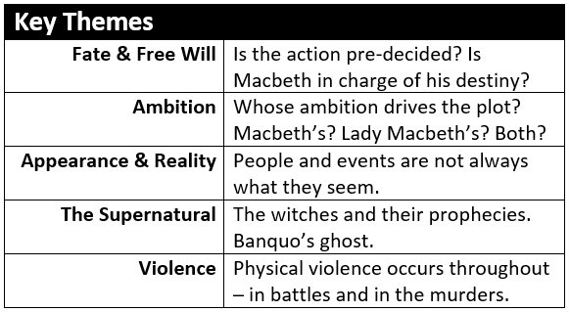
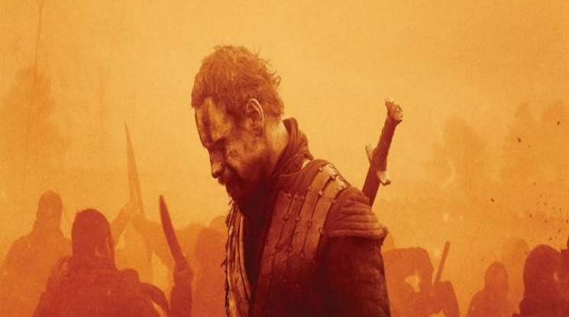

Macbeth
Read the following extract from Act 5 Scene 3 of Macbeth and then answer the question that follows.
At this point in the play Macbeth is under siege from the English army.

MACBETH
Bring me no more reports; let them fly all:
Till Birnam wood remove to Dunsinane,
I cannot taint with fear. What's the boy Malcolm?
Was he not born of woman? The spirits that know
All mortal consequences have pronounced me thus:
'Fear not, Macbeth; no man that's born of woman
Shall e'er have power upon thee.' Then fly, false thanes,
And mingle with the English epicures:
The mind I sway by and the heart I bear
Shall never sag with doubt nor shake with fear.
Enter a Servant

The devil damn thee black, thou cream-faced loon!
Where got'st thou that goose look?

Starting with this speech, explain how far you think Shakespeare presents Macbeth as a hero.
Write about:
- How Shakespeare presents Macbeth is this speech.
- How Shakespeare presents Macbeth in the play as a whole.

[30 marks]
AO4 [4 marks]

Macbeth
Read the following extract from Act 1 Scene 5 of Macbeth and then answer the question that follows.
At this point in the play Lady Macbeth is awaiting the arrival of King Duncan at her home.

LADY MACBETH
The raven himself is hoarse
That croaks the fatal entrance of Duncan
Under my battlements. Come, you spirits
That tend on mortal thoughts, unsex me here,
And fill me from the crown to the toe top-full
Of direst cruelty. Make thick my blood,
Stop up th’access and passage to remorse,
That no compunctious visitings of nature
Shake my fell purpose, nor keep peace between
Th’ effect and it. Come to my woman’s breasts,
And take my milk for gall, you murd’ring ministers,
Wherever in your sightless substances
You wait on nature’s mischief. Come, thick night,
And pall thee in the dunnest smoke of hell,
That my keen knife see not the wound it makes,
Nor heaven peep through the blanket of the dark,
To cry ‘Hold, hold!’

Starting with this speech, explain how far you think Shakespeare presents Lady Macbeth the driving force for the murder of King Duncan.
Write about:
- How Shakespeare presents Lady Macbeth is this speech.
- How Shakespeare presents Lady Macbeth in the play as a whole.

[30 marks]
AO4 [4 marks]

Macbeth
Read the following extract from Act 1 Scene 7 of Macbeth and then answer the question that follows.
At this point in the play Macbeth is debating if he should kill King Duncan.

MACBETH
If it were done when ’tis done, then ’twere well
It were done quickly. If th’assassination
Could trammel up the consequence, and catch
With his surcease success: that but this blow
Might be the be-all and the end-all, here,
But here upon this bank and shoal of time,
We’d jump the life to come. But in these cases
We still have judgement here, that we but teach
Bloody instructions which, being taught, return
To plague th’inventor. This even-handed justice
Commends th’ingredience of our poisoned chalice
To our own lips. He’s here in double trust:
First, as I am his kinsman and his subject,
Strong both against the deed; then, as his host,
Who should against his murderer shut the door,
Not bear the knife myself.

Starting with this speech, explain how far you think Macbeth is presented as a character who abandons his sense of right and wrong.
Write about:
- How Shakespeare presents Macbeth is this speech.
- How Shakespeare presents Macbeth in the play as a whole.

[30 marks]
AO4 [4 marks]

Extended Essay titles:
- ‘This dead butcher and his fiend-like queen’. How far is this a fair judgement on the characters of Macbeth and Lady Macbeth?
- How does the language in Macbeth’s soliloquies reflect the character’s state of mind?
- How do the witches’ prophecies influence and affect Macbeth’s actions?
- How does the recurring imagery in Macbeth add to the powerful atmosphere of the play?
- “Blood will have blood”: is Macbeth’s death inevitable from the moment he kills King Duncan?

King James, Witch Trials and Daemonologie
The North Berwick witch trials were the trials in 1590 of a number of Scottish people accused of witchcraft. They ran for two years and implicated seventy people. The confessions of the ‘witches’ were extracted by torture in Edinburgh.
As King James sailed to Copenhagen to marry Princess Anne of Denmark, a terrible storm hit their ship, causing them to seek shelter in Norway for several weeks. Somehow, this was blamed on various women in Denmark who confessed (probably after being tortured) to raising the storm through sorcery. Two were burned for their crime.
Scottish women were linked to the storms when Gillis Duncan confessed to her employer that she had developed an ability to heal herself. She would also regularly sneak out after dark. She could not explain her strange behaviour, so she was tortured – a result of which was her confession of witchcraft. She accused many others too.
The situation snowballed, with more than a hundred suspects arrested. Under torture, many confessed to meeting with the Devil and devoting themselves to his evil work – including poisoning the king and attempting to sink his ship.
King James established a court hear their trials. Two of the most horrific cases are detailed below...
Agnes Sampson
Sampson was an elderly woman who refused to confess. She suffered horribly – she was fastened to the wall of her cell by a witch’s bridle, an iron instrument with four sharp prongs forced into the mouth, so that two prongs pressed against the tongue, and two others against the cheeks. She was kept without sleep and strangled. Only after these ordeals did she confess to her ‘crimes’. She was hanged and burned as a witch.
Dr John Fian
Like Sampson, he refused to confess to witchcraft. His fingernails were forcibly removed, with iron pins thrust into his fingertips. Thumbscrews are also used to slowly crush his thumbs. A similar device called ‘the boot’ was used to crush his feet. He was finally burned at the stake having confessed.
Influenced by his involvement in the ‘attack’ upon his boat and his role in the subsequent trials, King James wrote his book Daemonologie in 1597.
DAEMONOLOGIE (edited extract)
My intention in this book, is only to prove two things, as I have already said: the one, that such devilish arts exist. The other, what exact trial and severe punishment they deserve: & therefore reason I, what kind of things are possible to be performed in these arts, & by what natural causes they may be, not that I touch every particular thing of the Devil’s power.
I say and prove, that Witches can, by the power of their Master, cure or cast on diseases: Now by these same reasons, that proves their power by the Devil of diseases in generally is as well proved their power in special: as of weakening the nature of some men, to make them unable for women: and making it to abound in others, more then the ordinary course of nature would permit. And such like in all other particular sicknesses.
How do you think what you’ve learned about King James I and Daemonologie influenced Shakespeare’s writing of Macbeth?

The Weird Sisters in Macbeth
Throughout the play, the witches—referred to as the “weird sisters” by many of the characters—lurk like dark thoughts and unconscious temptations to evil. In part, the mischief they cause stems from their supernatural powers, but mainly it is the result of their understanding of the weaknesses of their specific interlocutors—they play upon Macbeth’s ambition like puppeteers.
The witches’ beards, bizarre potions, and rhymed speech make them seem slightly ridiculous, like caricatures of the supernatural. Shakespeare has them speak in rhyming couplets throughout (their most famous line is probably “Double, double, toil and trouble, / Fire burn and cauldron bubble”), which separates them from the other characters, who mostly speak in blank verse. The witches’ words seem almost comical, like malevolent nursery rhymes. Despite the absurdity of their “eye of newt and toe of frog” recipes, however, they are clearly the most dangerous characters in the play, being both tremendously powerful and utterly wicked.
The audience is left to ask whether the witches are independent agents toying with human lives, or agents of fate, whose prophecies are only reports of the inevitable. Some of their prophecies seem self-fulfilling. For example, it is doubtful that Macbeth would have murdered his king without the push given by the witches’ predictions. In other cases, though, their prophecies are just remarkably accurate readings of the future—it is hard to see Birnam Wood coming to Dunsinane as being self-fulfilling in any way. The play offers no easy answers. Instead, Shakespeare keeps the witches well outside the limits of human comprehension. They embody an unreasoning, instinctive evil.

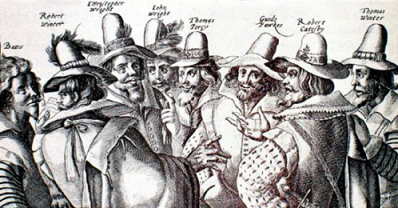
THE GUNPOWDER PLOT
After Queen Elizabeth I died, English Catholics who had been persecuted under her rule had hoped that the new king, James I, would be more tolerant of their religion. After all, King James had a Catholic mother. Unfortunately, he turned out to be no more tolerant than Elizabeth, and 13 young men decided that violent action was the solution.
A small group took shape under the leadership of Robert Catesby. He felt that the best course of action was to blow up the Houses of Parliament. In doing so, they would kill the king and the members of Parliament who were making life difficult for Catholics. Today, we’d call these people extremists or terrorists.
To carry out their plan, the conspirators obtained 36 barrels of gunpowder and hid them under the House of Lords. However, as the group worked on the plot, it became clear that innocent people would be killed or hurt in the attack, including some people who even fought for the rights of Catholics. Some of the plotters started having second thoughts. One of the group even sent a letter to his friend, Lord Monteagle, warning him to stay away from Parliament on the 5th of November.
This warning letter reached King James, and the King’s forces made plans to stop the conspirators. Guy Fawkes, who was in the cellar of Parliament with the gunpowder when the authorities stormed it, was caught, tortured and executed.
It’s unclear if the conspirators would ever have been able to pull off their plan if they had not been betrayed. Some have even suggested the gunpowder was so old it was practically useless. As they never actually got to ignite it, we can never know for certain.
The Gunpowder Plot struck a chord with the people of England. Even now, the reigning monarch only enters Parliament once a year, on what is called the State Opening of Parliament. Prior to the opening, the Yeoman of the Guard is sent to search the cellars. Even nowadays, the Queen and Parliament still observe this tradition.
And obviously, we still celebrate Guy Fawkes Night. On the night the plot was foiled, November 5th 1605, bonfires were set alight to celebrate the safety of King James. We still celebrate like this over 400 years later – burning effigies of Guy Fawkes on our own bonfires.
What does the plot tell us about how people respond to power?
______________________________________________________________________________________________________________________________________________________________________________________________________________________________________________________________________________________________________________________________________________________________________________
What does it tell us about the consequences of power?
______________________________________________________________________________________________________________________________________________________________________________________________________________________________________________________________________________________________________________________________________________________________________________
Essay titles:
- ‘This dead butcher and his fiend-like queen’. How far is this a fair judgement on the characters of Macbeth and Lady Macbeth?
- How does the language in Macbeth’s soliloquies reflect the character’s state of mind?
- How do the witches’ prophecies influence and affect Macbeth’s actions?
- How does the recurring imagery in Macbeth add to the powerful atmosphere of the play?
- “Blood will have blood”: is Macbeth’s death inevitable from the moment he kills King Duncan?

